Topic 6.6 Hormones, Homeostasis and Reproduction

Essential idea: Hormones are used when signals need to be widely distributed

Understandings:
- Insulin and glucagon are secreted by β and α cells of the pancreas respectively to control blood glucose concentration.
- Thyroxin is secreted by the thyroid gland to regulate the metabolic rate and help control body temperature.
- Leptin is secreted by cells in adipose tissue and acts on the hypothalamus of the brain to inhibit appetite.
- Melatonin is secreted by the pineal gland to control circadian rhythms.
- A gene on the Y chromosome causes embryonic gonads to develop as testes and secrete testosterone.
- Testosterone causes pre-natal development of male genitalia and both sperm production and development of male secondary sexual characteristics during puberty.
- Estrogen and progesterone cause pre-natal development of female reproductive organs and female secondary sexual characteristics during puberty.
- The menstrual cycle is controlled by negative and positive feedback mechanisms involving ovarian and pituitary hormones.

Applications and Skills:
- Application: Causes and treatment of Type I and Type II diabetes.
- Application: Testing of leptin on patients with clinical obesity and reasons for the failure to control the disease.
- Application: Causes of jet lag and use of melatonin to alleviate it.
- Application: The use in IVF of drugs to suspend the normal secretion of hormones, followed by the use of artificial doses of hormones to induce superovulation and establish a pregnancy.
- Application: William Harvey’s investigation of sexual reproduction in deer.
- Skill: Annotate diagrams of the male and female reproductive system to show names of structures and their functions.

Key Terms

Try the Quizlet activity here: https://quizlet.com/103578490/ib-biology-66-hormones-homeostasis-and-reproduction-flash-cards/

Hormones and Control

The endocrine system consists of _________________ which _________________ chemicals

called __________________ directly into the __________________.

Hormones travel in the blood to a _______________ organ or ____________________and bring

about a _________________. The response becomes a ________________ _______________.
Homeostasis literally means “_____________ ______________” - refers to the process of
keeping the internal body environment in a steady state.
This is very important - a great deal of the __________________ system and
____________________ nervous system is dedicated to homeostasis.

Investigate the Endocrine System here:
http://lcmrschooldistrict.com/roth/PowerPoint_Lectures/chapter34/videos_animations/endocrine_glands_v2.html
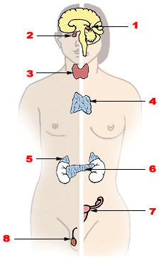

Identify the glands in the diagram:

1

2

3

4

5

6

7

8

Watch this video on negative and positive feedback:
https://www.sophia.org/tutorials/negative-and-positive-feedback-loops

Read this information and then complete the table to compare positive and negative feedback
http://anatomyandphysiologyi.com/homeostasis-positivenegative-feedback-mechanisms/

Type of feedback | Negative | Positive
Definition and explanation
Example 1
Example 2

Hormone Examples

Hormone | Details | Other information  (what can go wrong/medical uses)
Leptin | Secreted from:  Target organ:  Function:
Thyroxin | Secreted from:  Target organ:  Function:
Melatonin | Secreted from:  Target organ:  Function:
Insulin | Secreted from:  Target organ:  Function:
Glucagon | Secreted from:  Target organ:  Function:

Male and Female Reproductive System

Work through the animation here:
http://kisdwebs.katyisd.org/campuses/MRHS/teacherweb/hallk/Teacher%20Documents/AP%20Biology%20Materials/Body%20Systems/Human%20Reproduction/48_A02s.swf

Label the diagrams:

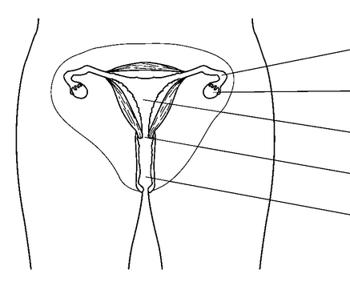

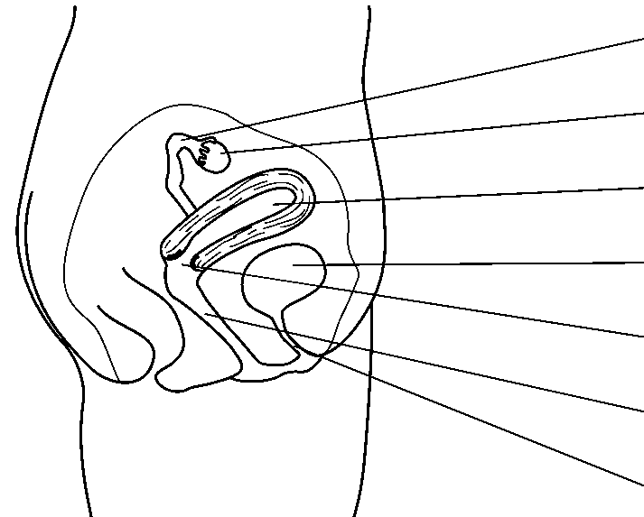

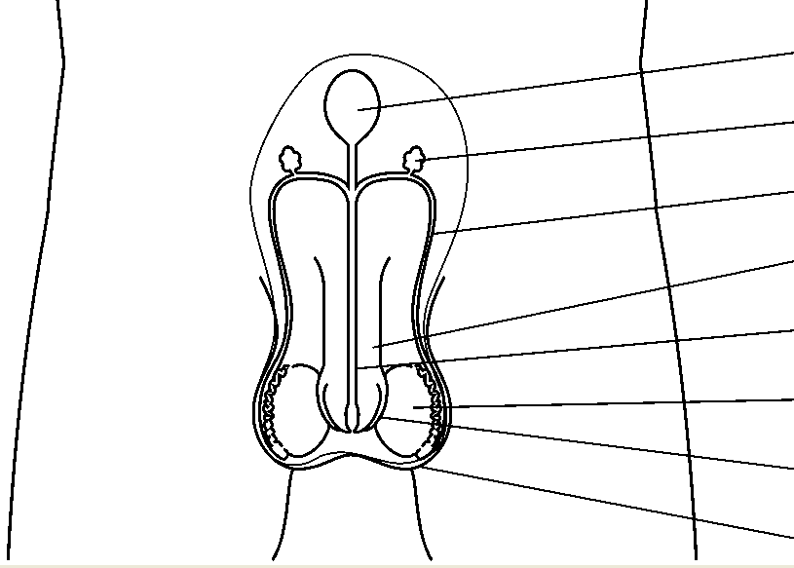

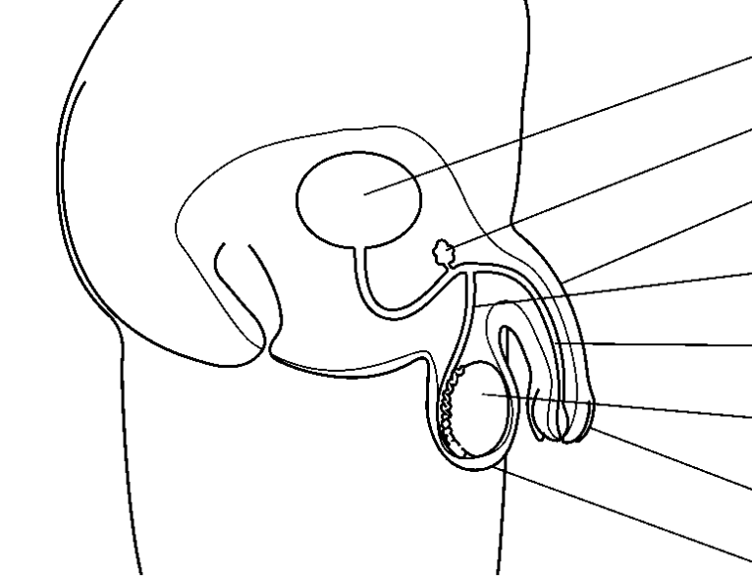

Match structure to function:

Female Reproductive System
Ureter | Stores urine
Urethra | Carries urine from the kidneys to the bladder
Vagina | The neck of the uterus
Bladder | Collects the egg released from the ovary and carries it to the uterus
Fallopian Tube (oviduct) | Contains ova and produces the female hormones oestrogen and progesterone
Uterus (womb) | Receives the penis during intercourse and is the way out for the baby during birth
Cervix | Carries urine out of the body
Ovary | Where the foetus (baby) develops

Male Reproductive System
Sperm duct | Add seminal fluid to make semen
Penis | Where sperm are stored before release
Testes | Carries semen from the testes to the penis
Scrotum | Where the sperm is made and the male hormone testosterone
Ureter | Protects and holds the testes outside the body
Urethra | Becomes erect for penetration
Epididymis | Carries urine from the kidneys to the bladder
Glands | Carries sperm from the testes to the urethra

Hormones in the Menstrual Cycle

Complete the table:
Name of hormone | Where it is made | Role in menstrual cycle

Watch the video: http://www.youtube.com/watch?v=nwo9KSNwSjE

Refer back to the interactive:
http://kisdwebs.katyisd.org/campuses/MRHS/teacherweb/hallk/Teacher%20Documents/AP%20Biology%20Materials/Body%20Systems/Human%20Reproduction/48_A02s.swf

On the axes below:
- Using different colours add lines to the graph to show how the levels of FSH, LH, oestrogen and progesterone change during the cycle.
- Label the follicular and luteal phases.
- Identify when ovulation occurs.
- Show how the lining of the uterus changes.

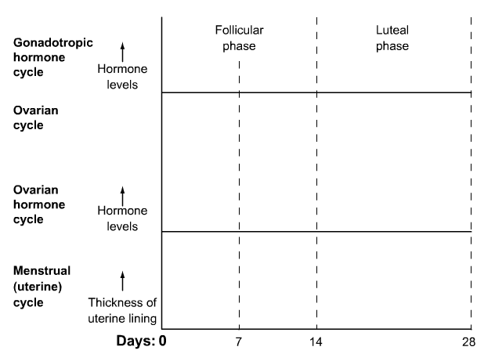

Explain what happens during the menstrual cycle using the graph:

Identify stages 1 to 6:
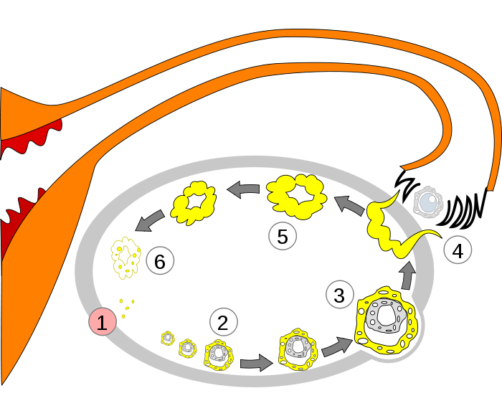

Testosterone

List some functions of testosterone in males.

Where is testosterone produced?

What group of biological molecules do the steroid hormones (including testosterone) belong
to? What component of cell membranes has a similar structure?

In vitro fertilization (IVF)

Go to http://www.sumanasinc.com/webcontent/animations/content/invitrofertilization.html
and work through the tutorial.

Watch this video:http://www.youtube.com/watch?v=GeigYib39Rs

Use the diagram to outline the main stages in the IVF procedure:

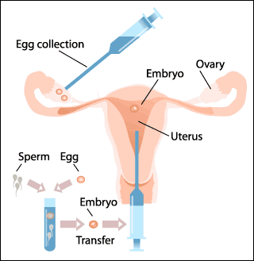

Read this article http://www.webmd.com/infertility-and-reproduction/guide/in-vitro-fertilization
and then answer the questions:

Identify some reasons why a couple might choose to use IVF:

What hormone is used and why?

How do physicians “aspirate oocytes”?

How many oocytes are typically removed?

What does “in vitro” mean?

How long do embryos typically develop out of uterus before being implanted?

How is the embryo inserted into the uterus?

How many embryos are typically inserted? Why?

What are the options for leftover embryos?

What is the typical success rate of IVF treatments?

Ethical issues associated with IVF

Read the article “The Ethics of In Vitro Fertilization” here:http://pedsinreview.aappublications.org/content/20/8/e28.full.pdf+html

Identify some pro’s and con’s of the IVF process and outline them in the table below:

Pro’s | Con’s

Watch these brilliant videos by Professor Robert Winston

Try IVF at home with sea urchins!http://www.youtube.com/watch?v=zmh8Xj5o-p0

And an interesting talk on how unlikely it is that we get pregnant at all:http://www.youtube.com/watch?v=54h8wLkND_Y

Past Paper Questions

1. The following diagram shows the human female reproductive system as seen from the side.

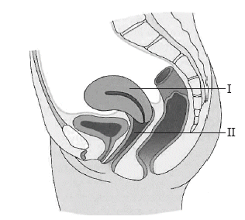

What are the names of the organs labelled I and II?

 | I | II
A. | uterus | vagina
B. | bladder | ovary
C. | urethra | oviduct
D. | clitoris | cervix
(1)

2. Which of the following is/are a role of testosterone in males?

I. Pre-natal development of male genitalia
II. Maintenance of sex drive
III. Increase in mental development

A. II only
B. I and II only
C. II and III only
D. I, II and III
(1)

3. Sketch the hormone changes between days 13 and 28 on the graphs below for a woman in her normal menstrual cycle.
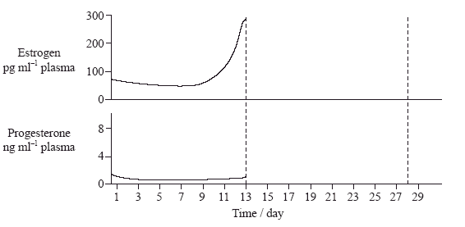
(2)

4. The hormones progesterone and LH were measured in a woman’s blood over 40 days. When did her menstrual bleed start?
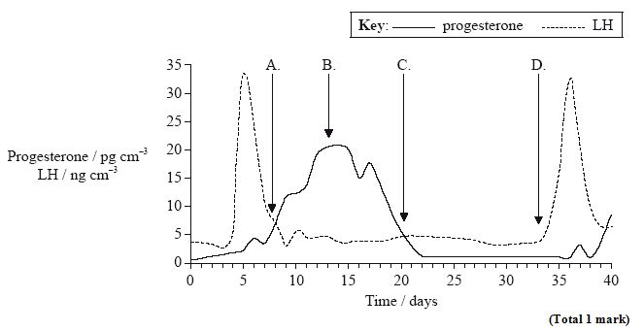

5. (a) Embryos that are produced by in vitro fertilization can be screened for genetic disease. Outline the process of in vitro fertilization, including one example of a situation when it is used.
(9)

