Topic 1.1 Introduction to Cells

Essential idea: The evolution of multicellular organisms allowed cell specialization and cell replacement.

Nature of science: Looking for trends and discrepancies—although most organisms conform to cell theory, there are exceptions.
Ethical implications of research—research involving stem cells is growing in importance and raises ethical issues.

Understandings:
• According to the cell theory, living organisms are composed of cells.
• Organisms consisting of only one cell carry out all functions of life in that cell.
• Surface area to volume ratio is important in the limitation of cell size.
• Multicellular organisms have properties that emerge from the interaction of their cellular components.
• Specialized tissues can develop by cell differentiation in multicellular organisms.
• Differentiation involves the expression of some genes and not others in a cell’s genome.
• The capacity of stem cells to divide and differentiate along different pathways is necessary in embryonic development and also makes stem cells suitable for therapeutic uses.

Applications and skills:
• Application: Questioning the cell theory using atypical examples, including striated muscle, giant algae and aseptate fungal hyphae.
• Application: Investigation of functions of life in Paramecium and one named photosynthetic unicellular organism.
• Application: Use of stem cells to treat Stargardt’s disease and one other named condition.
• Application: Ethics of the therapeutic use of stem cells from specially created embryos, from the umbilical cord blood of a newborn baby and from an adult’s own tissues.
• Skill: Use of a light microscope to investigate the structure of cells and tissues, with drawing of cells. Calculation of the magnification of drawings and the actual size of structures and ultrastructures shown in drawings or micrographs. (Practical 1)

The Cell Theory

Proposed by

The cell theory is made of three parts:

1.

2.

3.

Give one piece of evidence for each of these statements?

1.

2.

3.

What are some exceptions to the cell theory?

This is an interesting article to read about how cells evolved:
http://learn.genetics.utah.edu/content/begin/cells/organelles/

And here is a nice Cell Theory timeline:

http://www.timetoast.com/timelines/the-cell-theory-timeline

Functions of life

At IGCSE we use MRSGREN to help us remember the characteristics of living things. At IB we use different terms.

Define each term and give examples of how unicellular organisms carry out these processes.

metabolism

response

homeostasis

growth

reproduction

nutrition

Relative Sizes

http://learn.genetics.utah.edu/content/begin/cells/scale/

1 metre = 100 cm = 1000 mm = 1000000 um = 1000000000 nm

Structure | Actual size | Size in m | Size in scientific notation | Size relative to eukaryotic cell
Eukaryotic cell | up to  100 um | 0.0001m | 1 x 10 ⁻⁴ | 1
Cell organelles | up to  10 um
Prokaryotic cell | 1 um
Virus | 100 nm
Cell membrane | 10 nm
Glucose molecule | 1 nm
Water molecule | 0.1 nm

Imagine a eukaryotic cell was the size of a football field.
Can you find an object to represent each of the other items in the table?

Cell organelles
Prokaryotic cell
Virus
Cell membrane
Glucose molecule
Water molecule

Magnification

Define magnification:

What are the two ways that we can indicate magnification on an image?

What is the formula for calculating magnification?

Rules for magnification calculations:

1.

2.

3.

Calculate the actual size of this drawing:

Drawing of Paramecium caudatum
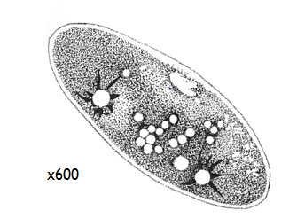

What is the average size of the chloroplasts in this plant cell if the image has a magnification of x9000?

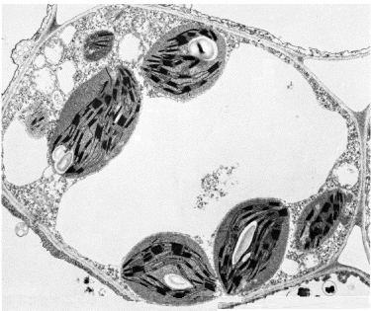

Scale Bars

Scale bars are added to micrographs (photos taken through a microscope) to give us an idea of the actual size of the object we are observing.

To calculate the magnification using a scale bar we have a different formula:

Calculate the magnification of these scale bars:
Calculate the magnification of this image using the formula above:
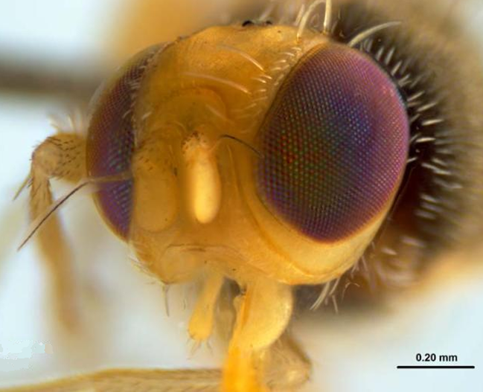

What is the width of the fly’s head?
Calculate the actual size of the mitochondria in the diagram below:

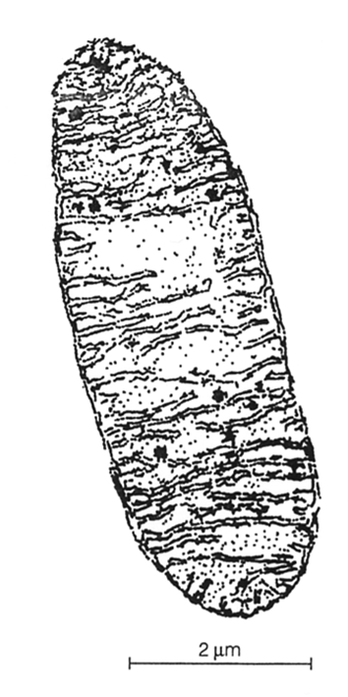

Past Paper Questions
1. A student views an image of a cell magnified 50000 times. The image is 60mm long.
a. What is the actual length of the sample in the image?

b. Is the cell more likely to be a plant cell, animal cell, bacterium or virus? Explain why.

2. A sperm cell has a tail 50μm long. A student draws it 50mm long. What is the magnification?

Limitations to cell size

Why can't cells continue to grow larger and larger to become giant cells? Why are most cells, whether from an elephant or an earthworm, microscopic in size? What happens when a cell grows larger and what causes it to divide into two smaller cells rather than growing infinitely larger? This investigation will provide you with a 'hands-on' activity that simulates the changing relationship of surface area-to-volume for a growing cell.

Importance: Changes in the surface area to volume ratio have important implications for limits or constraints on organism size, and help explain some of the modifications seen in larger-bodied organisms.
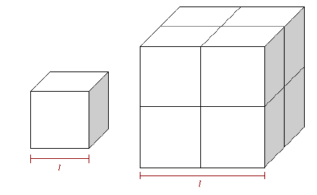
We'll begin with a reminder of some basic geometric formulae. The surface area and volume of a cube can be found with the following equations:

SA = 6xl² V = I³

Purpose: to determine the relationship between a cell’s size and its surface area to volume ratio.

Data collection and processing: Use the plastic blocks to create cubes of various sizes. Build at least 5 different sizes of cubes. Measure and record the side lengths of the cubes you build. Process your data by calculating the surface area, the volume, and the surface area to volume ratio for each cube you built. The surface area to volume ratio is calculated by dividing the surface area by the volume (please do the division calculation, don’t leave it as a ratio or fraction).

Show at least one worked example for each calculation.

Create a data table to record the data (with title and labels).

Raw Data:
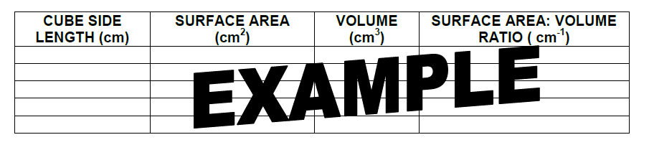

Data presentation: Present your data in a line graph. Plot cube side length (l) on the X axis and the surface area to volume ratio on the Y axis. Add a smooth curve between data points.
Analysis:
1. Which cube has the largest surface area? Which cube has the largest volume? Which cube has the largest surface area to volume ratio?

2. Describe the meaning of your graph in words. "As the cube side length increases, the surface area to volume ratio _______________. This means that…

3. Why are cubes used in this mini-lab rather than cells? Does this affect the validity of the results? Why or why not?

4. To maintain life, materials must be able to move into and out of a cell. What might be the advantage of having a large surface area?

5. What might be the disadvantage of having a large volume?

6. Cells are generally very small. Propose an explanation for why large organisms are made of more cells rather than larger cells.
Why SA:V ratio matters to cells:
The rate of exchange of substances into and out of the cell through the cell membrane depends on the organism's surface area that is in contact with the surroundings. The surface area of a cell is its plasma membrane.
The volume of a cell determines how many nutrients it needs (bigger = more) and how much waste it produces (bigger=more).
As a cell get bigger, its volume and surface area both get bigger, but not by the same amount. The volume increases as the cube but the area of the surface only increases by the square.
As a cell gets bigger, it has more demand for nutrients and makes more waste. However in a bigger cell there is relatively less surface area of the membrane for taking in the nutrients or getting rid of the waste.

Example: Gas exchange of oxygen for respiration.
Cells need oxygen for cell respiration.
A big cell needs more oxygen than a little cell.
Oxygen is obtained from the surrounding environment which could be water or blood (depends on the cell).
Oxygen diffuses across the cell membrane into the cell.
Big cells need to have more oxygen diffuse across the cell membrane than a little cell.
But the big cell has relatively small surface area compared to its volume i.e. the surface area: volume ratio is small.
Cells must not get too big because they cannot obtain sufficient oxygen to satisfy the demands of the cell.

Emergent Properties

Multicellular organisms show emergent properties. Explain what this means using an example.

Review Past Paper Questions

1. Which of the following will contribute to the cell theory?
I. Living organisms are composed of cells.
II. All cells come from pre-existing cells by mitosis.
III. Cells are the smallest units of life.
A. I only
B. II only
C. I and III only
D. I, II and III

2. What is the correct order of increasing size for the following biological structures?
I. The width of a virus
II. The width of a bacterium
III. The thickness of a cell surface membrane
IV. The diameter of a eukaryotic cell
A. I -> III -> II -> IV
B. I -> III -> IV -> II
C. III -> I -> II -> IV
D. III -> II-> I -> IV

3. Which of the following characteristics found in a structure necessarily indicates that it is alive?
A. The presence of genetic material
B. The presence of a lipid bilayer
C. Metabolism
D. Movement

4. If a mitochondrion has a length of 5 µm and a student’s drawing of the mitochondrion is 10 mm, what is the magnification of the drawing?
A. ×0.0005
B. ×0.5
C. ×200
D. ×2000

5. In a cell, what is the effect of a large surface area to volume ratio?
A. Slower rate of exchange of waste materials
B. Faster heat loss
C. Faster rate of mitosis
D. Slower intake of food

6. Below is a micrograph of an E. coli bacterium undergoing reproduction.
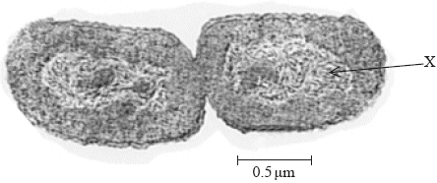
The scale bar represents 0.5 μm. How long are both cells in total?
A. 5.0 × 10–6 m
B. 5.0 × 10–9 m
C. 2.5 × 10–6 m
D. 2.5 × 10–9 m

7. How does the surface area to volume ratio change with an increase in cell size?

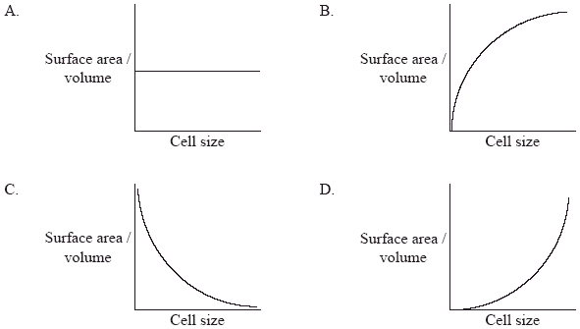

Stem Cells and Cell Differentiation

Look at the animations at these links:
http://www.sumanasinc.com/webcontent/animations/content/stemcells_scnt.html
http://www.dnalc.org/resources/animations/stemcells.html

Answer the questions using the links below:
http://learn.genetics.utah.edu/content/tech/stemcells/scintro/

a) What is a stem cell?

b) How does differentiation occur?.

c) What does pluripotent mean?

http://www.ns.umich.edu/stemcells/022706_TabA.html

d) What is the difference between embryonic stem cells, umbilical cord stem cells and adult stem cells?

e) How do bone marrow transplants help cancer patients?

http://news.bbc.co.uk/2/hi/health/7735696.stm

f) What was damaged by Tuberculosis?

g) How did they remove the cells from the donor airway/trachea?

h) Why did the doctors cover the donated trachea with Ms Castillo's own cells?

i) What could be encouraged to grow into windpipe cells?

j) What does Professor Birchall think will happen in 20 years time?

http://www.bbc.co.uk/schools/gcsebitesize/science/21c_pre_2011/genetics/cloningstemcellsrev2.shtml
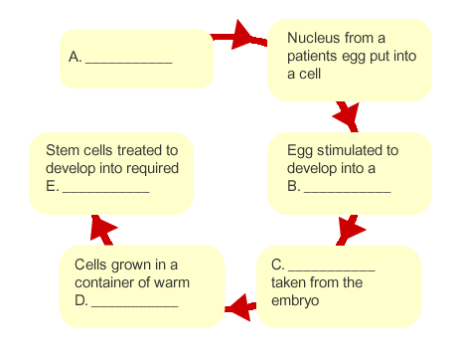
http://www.ns.umich.edu/stemcells/F_030606a.html

l) Why might nuclear transfer be considered superior to stem cells from embryos?

m) Why can’t nuclear transfer blastocysts become cloned humans?
https://apps.childrenshospital.org/clinical/animation/stemcell/

Once removed, stem cells can be ‘coaxed’ into becoming different types of cell.
Play with the coaxing agents to generate different types of cell:

n) What combination of coaxing agents do you need to make heart cells?

o) What could heart cells be used for?

p) What combination of coaxing agents do you need to make dopamine neurons?

q) Who could dopamine neurons be used for?

r) What combination of coaxing agents do you need to make red blood cells?

s) Who could red blood cells be used for?

Therapeutic Use of Stem Cells

Outline the symptoms and cause of Stargardt’s disease.

Explain how stem cells have been used in the treatment of this disease.

Use the links in the presentation to outline the successful treatment of one other named disease using stem cells.

