1.4 Membrane Transport

Essential idea: Membranes control the composition of cells by active and passive transport.

Nature of science: Experimental design—accurate quantitative measurement in osmosis experiments are essential.

Understandings:
• Particles move across membranes by simple diffusion, facilitated diffusion, osmosis and active transport.
• The fluidity of membranes allows materials to be taken into cells by endocytosis or released by exocytosis. Vesicles move materials within cells.

Applications and skills:
• Application: Structure and function of sodium–potassium pumps for active transport and potassium channels for facilitated diffusion in axons.
• Application: Tissues or organs to be used in medical procedures must be bathed in a solution with the same osmolarity as the cytoplasm to prevent osmosis.
• Skill: Estimation of osmolarity in tissues by bathing samples in hypotonic and hypertonic solutions. (Practical 2)

Diffusion and Osmosis
Watch this:
http://highered.mcgraw-hill.com/sites/0072495855/student_view0/chapter2/animation__how_diffusion_works.html

http://highered.mcgraw-hill.com/sites/0072495855/student_view0/chapter2/animation__how_osmosis_works.html

Define:

Diffusion

Osmosis

What needs to be present for both diffusion and osmosis to occur?

Passive Transport

Complete the table for the 3 types of passive transport:
Method of Transport | Through which part of membrane | Direction of movement | Energy required | Example of substances
Diffusion

Osmosis

Facilitated diffusion

Try this past paper question:
(a) Define osmosis.
.....................................................................................................................................
....................................................................................................................................(1)

(b) Outline how transport occurs across membranes by facilitated diffusion.
.....................................................................................................................................
.....................................................................................................................................
.....................................................................................................................................
....................................................................................................................................(2)

(c) Explain how the properties of phospholipids help to maintain the structure of cell membranes.
.....................................................................................................................................
.....................................................................................................................................
.....................................................................................................................................
....................................................................................................................................(3)
(Total 6 marks)

Go to: http://www.teachersdomain.org/asset/tdc02_int_membraneweb/

Click on each of the substances in turn to find out how it crosses the membrane.
Complete the table:
Name of Substance | Method of Transport | Explanation

Active Transport

Complete the table:
Energy required?
Type of substances moved
Examples of substance moved
Direction of movement

2.4.7 Vesicles and The Endomembrane System

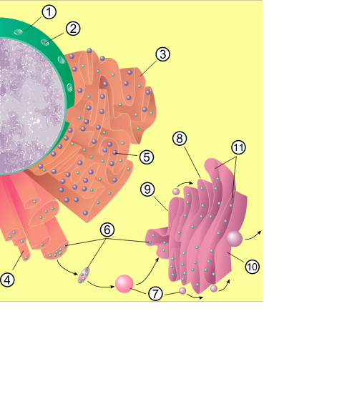
Identify structures 1 - 11 and explain the role of the endomembrane system:

Watch the animation at:
http://www.phschool.com/science/biology_place/biocoach/cells/endoreview2.html

Fill in the blanks:
Proteins destined for secretion are made on ______________ bound to the ________.
The proteins move through the endomembrane system and are dispatched from the trans face of the _____________ ______________ in transport _______________that move through the cytoplasm and then fuse with the _____________ ________________ releasing the protein to the outside of the cell. Examples of secretory proteins are collagen, ___________________, and digestive enzymes of the _______________ and intestine.

Watch:
http://highered.mcgraw-hill.com/olcweb/cgi/pluginpop.cgi?it=swf::535::535::/sites/dl/free/0072437316/120068/bio02.swf::Endocytosis%20and%20Exocytosis
and
http://bcs.whfreeman.com/thelifewire8e/content/cat_040/0504003.html

Complete the table:
Type of bulk transport | Description/definition | Examples
Phagocytosis
Pinocytosis
Receptor mediated endocytosis
Endocytosis

Define:

Endocytosis

Exocytosis

Explain the meanings of the following:

Secretory vesicles

Invagination

Describe and explain the role of bulk transport in the following situations.
A diagram might help.

Amoeba nutrition

Hormone production

(a) Outline how vesicles are used to transport materials secreted by a cell. (6)

(b) Draw a labelled diagram to show the structure of a membrane.(5)

(c) Describe the process of endocytosis.(5)

