1.6 Cell Division

Essential idea: Cell division is essential but must be controlled.

Nature of science: Serendipity and scientific discoveries—the discovery of cyclins was accidental.

Understandings:
• Mitosis is division of the nucleus into two genetically identical daughter nuclei.
• Chromosomes condense by supercoiling during mitosis.
• Cytokinesis occurs after mitosis and is different in plant and animal cells.
• Interphase is a very active phase of the cell cycle with many processes
occurring in the nucleus and cytoplasm.
• Cyclins are involved in the control of the cell cycle.
• Mutagens, oncogenes and metastasis are involved in the development of
primary and secondary tumours.

Applications and skills:
• Application: The correlation between smoking and incidence of cancers.
• Skill: Identification of phases of mitosis in cells viewed with a microscope or in
a micrograph.
• Skill: Determination of a mitotic index from a micrograph.

Work your way through the interactive tutorial here: http://www.wiley.com/college/test/0471787159/biology_basics/animations/mitosis.swf

Use the information to add labels to the diagram. Name each stage and explain what is happening.

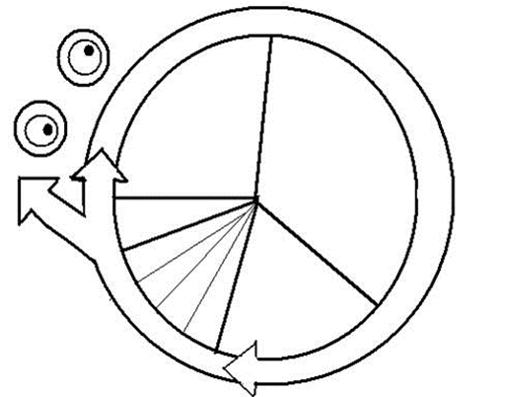

You might also find help on these sites:
http://outreach.mcb.harvard.edu/animations/cellcycle.swf and http://highered.mcgraw-hill.com/sites/0072495855/student_view0/chapter2/animation__how_the_cell_cycle_works.html

Go to http://www.youtube.com/watch?v=1cVZBV9tD-A and watch the video about mitosis.

Look at the following animations: http://www.johnkyrk.com/mitosis.html and
http://highered.mcgraw-hill.com/sites/0072495855/student_view0/chapter2/animation__mitosis_and_cytokinesis.html

Now complete the table:
Name of Stage | Diagram | What is happening?
Interphase G1
Interphase S
Interphase G2
Prophase
Metaphase
Anaphase
Telophase
Cytokinesis

Answer the following questions:
a) What is the purpose of mitosis?

b) What is a centriole (in the US a centrosome) and what does it do? Which types of cells have them?

c) What is the equatorial plate?

d) How does cytokinesis differ in plant and animal cells?

e) Define

Chromosome

Chromatin

Gene

f) Draw pictures to illustrate the following:

Chromatin

Chromatid

Un-replicated chromosome

Replicated chromosome.

g) At which stage(s) in the cell cycles is each of the above features present?
Chromatin
Chromatid
Un-replicated chromosome
Replicated chromosome

h) What are kinetochores and kinetochore microtubules?

Timing of the Cell Cycle Lab

The relative length of time required for the completion of the cell cycle is directly correlated with the number of cells observed in the various stages. From this information and how long the cycle takes, the time sequence of each of these stages can be worked out. Follow these steps:

Data collection table
Observe every cell in in the two images of onion root tip tissue and determine which phase of the cell cycle it is in. The observable phases are:
1. Interphase
2. Prophase
3. Metaphase
4. Anaphase
5. Telophase/cytokinesis (these stages often happen simultaneously).

This is best done in pairs. The partner observing the images calls out the phase of each cell while the other partner records. Then switch so the recorder becomes the observer and visa versa.

Record your results in an IB quality data collection table.

Data Processing Table and Graph
In a data processing table, convert the number of cells in each stage of the cell cycle to a percentage.

In an onion root tip, the mitotic cycle generally takes about 24 hours. This is an approximation; the actual time may vary depending on the condition of the roots during growth.

On the basis of a 24-hr cycle, work out the approximate time in hours and minutes that is spent in each stage. Include this information in your data processing table.

WARNING!: a common mistake is incorrectly converting decimals to minutes. For example many people would incorrectly say that 10.33 hours is 10 hours and 33 minutes, when it is actually 10 hours and 20 minutes.

Show a worked example calculation for 1) the percentage of cells and 2) the time per each stage.

Create an appropriate IB quality graph that displays the time of a 24 hour cycle for each stage of the cell cycle.

Questions (answer in complete sentences)
1. Which of the stages is the shortest? Does this support what you have already learned about the behaviour of the chromosomes? Explain.
2. Which of the stages seems to be the longest in duration? Does this support what you have already learned about the behaviour of the chromosomes? Explain.
3. If your observations had not been restricted to the area of the root tip that is actively dividing, how would your results have been different?

Which stage?
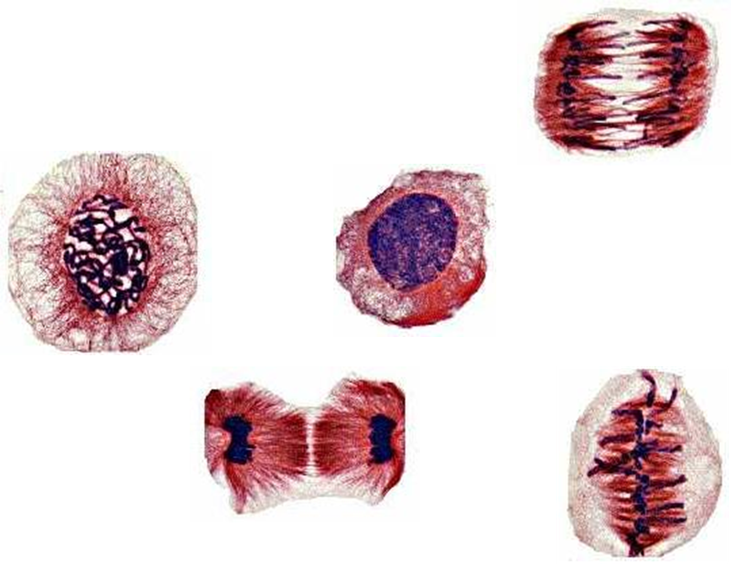

Inside Cancer

View the presentations about cancer at the Inside Cancer web site http://www.insidecancer.org/ and answer the following questions.
Click through the presentations using the arrow at bottom right of the screen.

Part 1: Hallmarks of Cancer
Overview
1. Where in the body can cancer arise?

2. Why does cancer risk increase with age?

Growing Uncontrollably
3. How are cancer cells different than normal cells when responding to signals that regulate the cell cycle?

Evading Death
4. Compare apoptosis cell death in normal cells and in cancer cells.

Processing Nutrients
5. Define angiogenic.

6. Why do cancer cells need to become angiogenic?

7. What nutrients do cells need to transport into the cell?

8. What wastes do cells need to transport out of the cell?

Becoming Immortal
9. What is a telomere?

10. In a normal cell, what happens to the telomere DNA over the course of multiple cell divisions?

11. What is telomerase? In what cells is telomerase normally functioning?

12. What does telomerase do in cancer cells?

Invading Tissues
13. What is metastasis?

14. In general, why can cancer be deadly?

Avoiding Detection
15. What is the function of B cells in the immune response?

16. What is the function of T cells in the immune response?

17. What is adjuvant therapy?
Promoting Mutations
18. How are gene mutations acquired in cells? (3 ways)

19. How many genes on average are changed to get a cancer?

Part 2: Causes and Prevention
Overview

20. What percent of cancers are inherited?

21. What percent of cancers are due to synthetic chemicals?

22. For each cancer, indicate its leading cause and location of highest global incidence.
  - Lung Cancer:

  - Liver Cancer:

  - Stomach Cancer:

  - Skin Cancer:

  - Breast Cancer:

  - Cervical Cancer:

  - Colon Cancer:

Smoking
23. Select the link to Lung cancer epidemic. For each cancer, indicate what percent of cancer deaths each cancer cause and the number of Americans that die each year because of the cancer.
Cancer Type | Percent of Cancer Deaths | Number of Deaths / Year
Lung
Colon
Breast
Pancreas
Prostate
Leukemia
Lymphoma
Ovary
Liver
Esophagus
Bladder
Brain
Kidney
Stomach
Myeloma
Uterine
Skin
Others

24. Select the link to Killers in Smoke. With each inhale, how many cancer causing chemicals does a smoker inhale?

25. Select the link to Smoking Gun. How does Benzo[a]pyrene, a chemical in cigarette smoke, mutate DNA?

26. Select the link to K-ras. What is the normal function of the K-ras protein? What happens if the K-ras gene is mutated?

27. Select the link to p53 and answer the following questions:
o What is the function of the p53 protein?

o At what points in the cell cycle is the p53 protein active?

o What happens if p53 is mutated?

28. Select the link to Nicotine Connection and answer the following questions:
o What is Akt?

o What activates Akt?

o What is Akt’s role in the development of cancer?

Diet
29. What foods and cooking methods have been associated with cancer development?

Part 3: Pathways to Cancer
Click through each of the remaining segments within the pathways to cancer section to view an animation of signal transduction and protein synthesis.

Past Paper Question

Describe the events that occur during mitosis (9 marks)

