2.7 DNA Replication, Transcription and Translation

Understandings
• The replication of DNA is semi-conservative and depends on complementary base pairing.
• Helicase unwinds the double helix and separates the two strands by breaking hydrogen bonds.
• DNA polymerase links nucleotides together to form a new strand, using the pre-existing strand as a template.
• Transcription is the synthesis of mRNA copied from the DNA base sequences by RNA polymerase.
• Translation is the synthesis of polypeptides on ribosomes.
• The amino acid sequence of polypeptides is determined by mRNA according to the genetic code.
• Codons of three bases on mRNA correspond to one amino acid in a polypeptide.
• Translation depends on complementary base pairing between codons on mRNA and anticodons on tRNA.

Applications and Skills
• Application: Use of Taq DNA polymerase to produce multiple copies of DNA rapidly by the polymerase chain reaction (PCR).
• Application: Production of human insulin in bacteria as an example of the universality of the genetic code allowing gene transfer between species.
• Skill: Use a table of the genetic code to deduce which codon(s) corresponds to which amino acid.
• Skill: Analysis of Meselson and Stahl’s results to obtain support for the theory of semi-conservative replication of DNA.
• Skill: Use a table of mRNA codons and their corresponding amino acids to deduce the sequence of amino acids coded by a short mRNA strand of known base sequence.
• Skill: Deducing the DNA base sequence for the mRNA strand.

DNA Replication
DNA replication is a way of copying one DNA strand to make two new molecules with the same base sequence. We refer to DNA replication as being semi-conservative as each new molecule consists of one new strand and one old strand that is conserved from the original parent DNA molecule.

Watch these animations: http://highered.mcgraw-hill.com/sites/0072943696/student_view0/chapter3/animation__dna_replication__quiz_1_.html and http://www.johnkyrk.com/DNAreplication.html

STAGE 1 Before the DNA can start to replicate the double helix must be unwound & the strands separated.

What bond must be broken between the nitrogenous bases?

What is the main enzyme in charge of catalyzing (speeding up) the unwinding & separation of the two strands?

STAGE 2 What is meant by the template strand?

What is DNA polymerase & what role does it play in forming the new complementary DNA strand?

What bonding will be involved as the new nucleotides are linked together?

What are Okazaki fragments and why are they produced?

What is the role of DNA ligase?

STAGE 3 The daughter DNA molecules each rewind to form the double helix structure. Each of the new strands is complementary to the template on which it was made and identical to the other template.

Semiconservative Replication

The Meselson/Stahl experiment demonstrated the semiconservative replication of DNA.

Watch the animations
http://highered.mcgraw-hill.com/olcweb/cgi/pluginpop.cgi?it=swf::535::535::/sites/dl/free/0072437316/120076/bio22.swf::Meselson%20and%20Stahl%20Experiment

and http://www.sumanasinc.com/webcontent/animations/content/meselson.html

Now summarise the experiment in your own words. A diagram might be useful here:

DNA Replication Drawing

Using pencil, you will draw a representation of DNA replication along the leading and lagging strands. Follow the directions below, drawing each element in its proper location along the replicating DNA strand. Once you are sure everything is in the correct place, complete your drawing by adding color to distinguish objects as separate.

- On the diagram below, label the 5’ and 3’ ends of both parental DNA strands (you can make up which is which)
- Label the replication fork
- Draw and label helicase
- Label the overall direction of DNA replication
- Draw and label single stranded binding proteins
- Draw and label the leading strand
- Draw and label a single DNA polymerase III on the leading strand
- Draw and label an RNA primer on the leading strand
- Draw and label a DNA polymerase I on the leading strand
- On the lagging strand, draw and label at least three Okazaki fragments
- On the lagging strand, draw and label at least two DNA polymerase III enzymes
- On the lagging strand, draw and label at least two RNA primers
- On the lagging strand, draw and label at least one primase enzyme
- On the lagging strand, draw and label at least one DNA polymerase I enzyme
- On the lagging strand, draw and label at least one DNA ligase enzyme

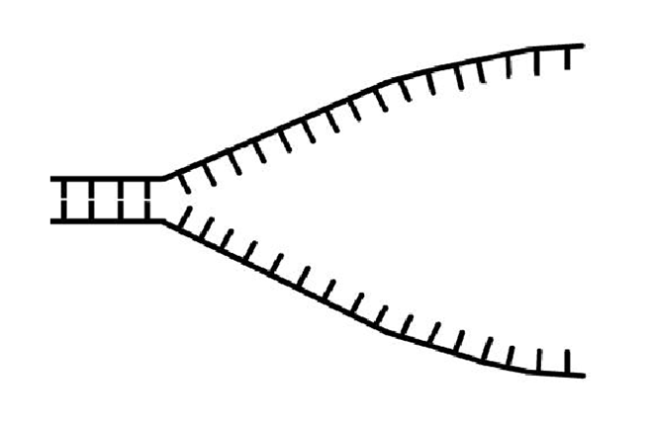

DNA Replication
Put the sentences in the correct order
… nucleotides in a 5’ to 3’ direction (in the ….
… is needed for building up a complementary strand for this template.
To this primer, DNA polymerase III adds nucleotides in a 5’ ® 3’ direction, moving…
… sealed up by DNA ligase which makes a sugar-phosphate bond between adjacent DNA fragments.
The DNA double helix is uncoiled and the two strands are…
… DNA polymerase III can follow along behind it, adding nucleotides in one continuous strand., however…
… a short length of RNA to the template strand of DNA, which acts as a primer.
… away from the replication fork as it does so. In this way…
… replication fork will be opening up in the opposite direction: another method, therefore,…
… short lengths of DNA – called Okazaki fragments - are formed between RNA primers.
… separated by the enzyme Helicase, producing a replication fork.
… reproduce or ‘replicate’ a double helix with anti-parallel strands.)
… the RNA primer and replaces it with DNA. A gap is left where…
…because the template strands are anti-parallel, for the other template strand, the…
At regular intervals along the lagging strand, RNA primase adds …
Behind the replication fork, the enzyme DNA polymerase III adds…
Next, DNA polymerase I removes…
… two nucleotides are still left unconnected – this gap is…
opposite direction to the direction of the bases in the template strand, so as to…
As DNA helicase moves along one of the anti-parallel template strands …

PCR

Watch the animation here: http://learn.genetics.utah.edu/content/labs/pcr/

What does PCR stand for?

Name some uses of PCR:

What is the role of each of the following in PCR:

Primers

DNA polymerase

Nuceotides

The DNA polymerase used in the PCR process comes from a strain of bacteria called Thermus aquaticus that live in the hot springs of Yellowstone National Park.
What is special about it and why is it used?

Briefly describe the steps in the process of PCR using the diagram below:
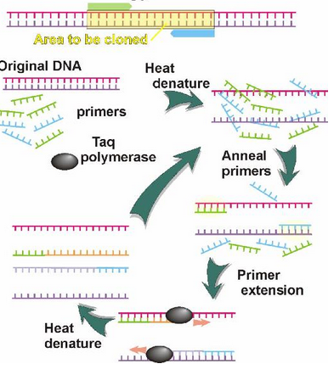
.

Transcription

Define

Transcription

RNA polymerase

Go to: http://www.stolaf.edu/people/giannini/flashanimat/molgenetics/transcription.swf

Add the following labels to the diagram:

RNA polymerase, DNA, mRNA, template strand, arrow showing the direction of transcription

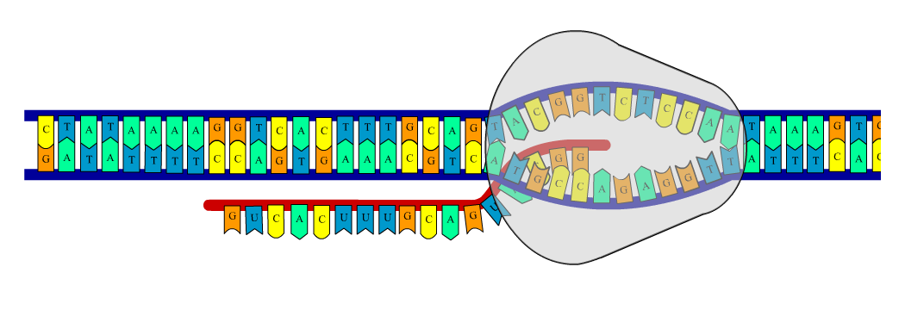

Put the sentences in order to describe what happens during the process of transcription:
The DNA double helix unzips
The two DNA strands join together by complementary base pairing
RNA polymerase forms sugar-phosphate bonds between nucleotides.
as hydrogen bonds between complementary bases break
The DNA molecules winds back up into a helix
One strand called the sense strand acts as a template
and passes through the nuclear membrane into the cytoplasm.
to the exposed bases on this strand by forming hydrogen bonds.
and the two polynucleotide strands separate.
Once complete, the mRNA detaches from the sense strand
and free RNA nucleotides complementary base pair

Define these terms

Gene

Genetic code

Codon

The genetic code is said to be universal, degenerate and non-overlapping. With the aid of diagrams explain the meaning and significance of each of these terms.

Universal

Degenerate

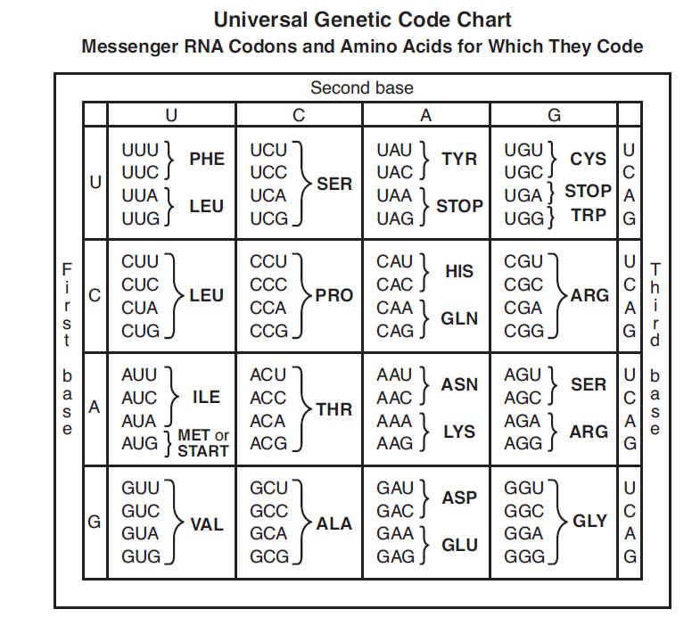
Non-overlapping

Are there exceptions to any of these rules?

Translation

Define:

Translation

Explain the roles of the following in translation:

Ribosome

tRNA

Anticodon

Draw and label a diagram of a tRNA molecule and label the anticodon and site of attachment of the amino acid:

Add labels to the diagram:
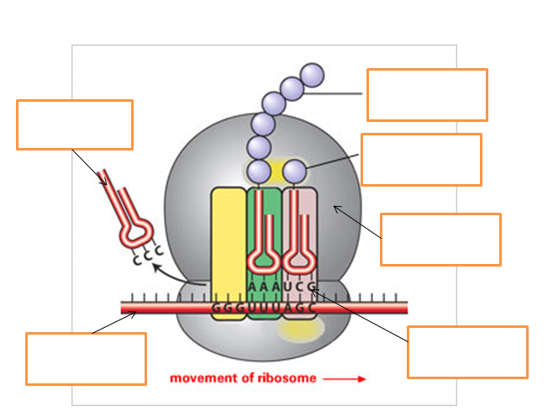

Complete the paragraphs describing the process of translation and draw a diagram to show what is happening:

When a small subunit of a ______________ charged with a tRNA + the amino acid methionine encounters an mRNA, it attaches and starts to scan for a ____________ signal. When it finds the start sequence _________, the codon for the amino acid methionine, the large subunit joins the small one to form a complete ribosome and the protein synthesis is initiated.
A new tRNA+amino acid enters the ribosome, at the next codon downstream of the AUG codon. If its ___________matches the mRNA codon it ________ _________ and the ribosome can link the two amino acids together. The ribosome then moves one __________ forward and a new tRNA+amino acid can enter the ribosome and the procedure is repeated.
When the ribosome reaches one of three __________ codons, for example ________, there are no corresponding tRNAs to that sequence. Instead _________________ (the protein), is released and the ribosome dissociates from the mRNA.. Some cells need large quantities of a particular protein. To meet this requirement they make many ________ copies of the corresponding gene and have many _____________ working on each mRNA.
One gene one protein
What is the “central dogma” of molecular biology?

Explain the one gene one peptide theory.

Describe some exceptions to this theory.

