6.5 Neurons and Synapses

Understandings:
- Neurons transmit electrical impulses.
- The myelination of nerve fibres allows for saltatory conduction.
- Neurons pump sodium and potassium ions across their membranes to generate a resting potential.
- An action potential consists of depolarization and repolarization of the neuron.
- Nerve impulses are action potentials propagated along the axons of neurons.
- Propagation of nerve impulses is the result of local currents that cause each successive part of the axon to reach the threshold potential.
- Synapses are junctions between neurons and between neurons and receptor or effector cells.
- When presynaptic neurons are depolarized they release a neurotransmitter into the synapse.
- A nerve impulse is only initiated if the threshold potential is reached.

Applications and Skills:
- Application: Secretion and reabsorption of acetylcholine by neurons at synapses.
- Application: Blocking of synaptic transmission at cholinergic synapses in insects by binding of neonicotinoid pesticides to acetylcholine receptors.
- Skill: Analysis of oscilloscope traces showing resting potentials and action potentials.
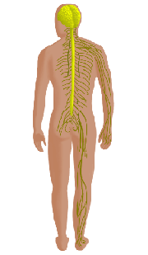
Control Systems

What are the names of the two systems that control our bodies?

What are the two main parts of the nervous system?

What makes up the central nervous system?

Label the CNS, brain, spinal cord and peripheral nerves on the diagram:

Membrane Proteins

Complete the table:

Membrane Protein | Function | Substances transported | ATP needed?  Y or N

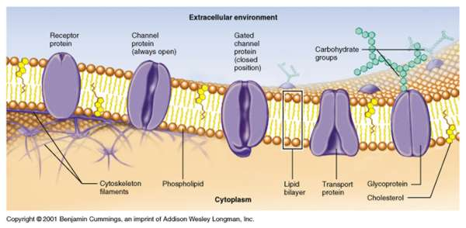

Neuron Structure

Draw and label a motor neuron in the space below.

Go to http://sites.sinauer.com/neuroscience5e/animations02.01.html

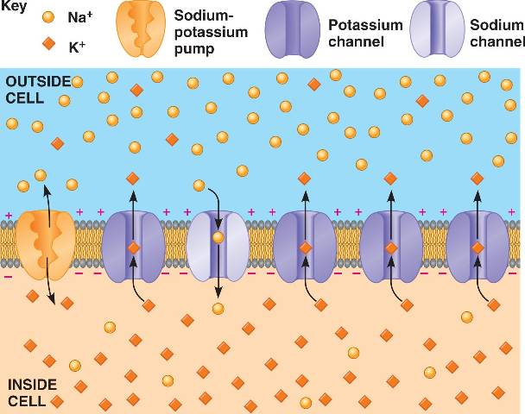
Define:
Resting potential

Put the sentences in order to explain how a resting potential is achieved:

1 | This requires ATP
2 | Sodium and potassium cation pumps transport Na+ out and K+ in
3 | Concentration of Na+ is high outside the neuron
4 | This results in the inside being more negative than the outside
5 | Concentration of K+ is high inside the neuron
6 | Membrane is more permeable to K+ than Na+
7 | Difference in concentration of ions maintained by active transport against concentration gradient
8 | Concentration of K+ inside neuron 20x greater than outside so K+ ions rapidly diffuse out until equilibrium reached

How do neurons transmit a nervous impulse?

Watch the Action Potential animations:
http://outreach.mcb.harvard.edu/animations/actionpotential_short.swf
http://highered.mcgraw-hill.com/sites/0072495855/student_view0/chapter14/animation__the_nerve_impulse.html

Define:
Action potential:

____________________ can reverse the charge on a neuron (-70 to +40 mV). The membrane
becomes _______________________. If the stimulus exceeds a certain ____________________
value an _______________________________ results.

Define
Depolarisation:

Repolarisation:

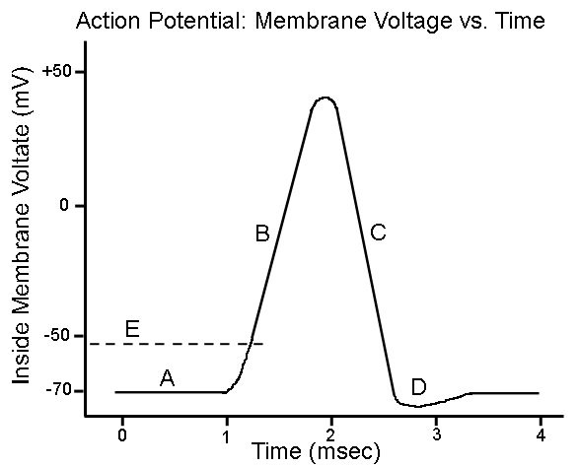
Label the graph showing the changes in potential difference across the nerve as a nervous impulse is transmitted. Words to use: Depolarisation, repolarisation, resting potential, action potential, threshold value, point of stimulus, refractory period and resting state.

Synaptic Transmission

Watch theanimation: http://highered.mcgraw-hill.com/sites/0072495855/student_view0/chapter14/animation__transmission_across_a_synapse.html

Define Synapse:

Why do we need synapses?

Label this diagram of a synapse:
Include these labels - pre-synaptic neuron, post-synaptic neuron, mitochondria, vesicle, neurotransmitter, synaptic cleft, calcium ions, voltage gated calcium channels, action potential, sodium channel, neutrotransmitter receptor
Identify what is happening at each stage:

1

2

3

4

5

6

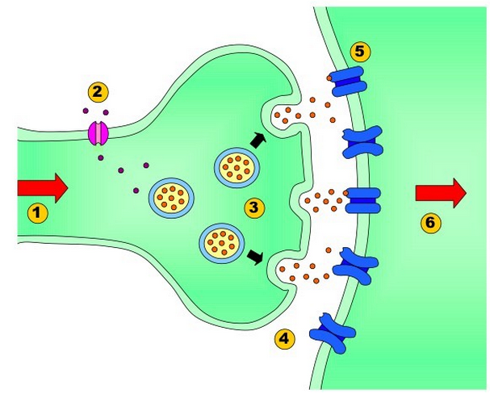

Past Paper Questions

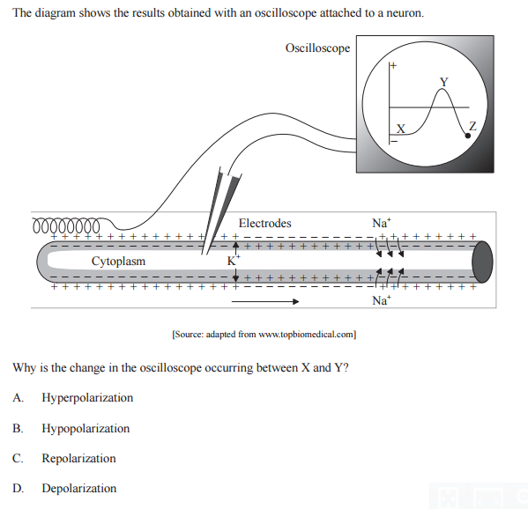

2. Draw and label a diagram of a motor neuron showing the direction of nerve impulse propagation (3)

3. Explain how a nerve impulse passes along a non-myelinated neuron (8)

4. Explain the principles of synaptic transmission (8)

5. Outline the use of four method of membrane transport in nerves and synapses (8)

