Topic 5. Enzymes

Define the term catalyst
A catalyst is a substance that increases the rate of a chemical reaction and is not changed by the reaction

Define enzymes
Enzymes are proteins that function as biological catalysts
Describe why enzymes are important in all living organisms in terms of reaction speed necessary to sustain life

Describe enzyme action with reference to the complementary shape of an enzyme and its substrate and the formation of a product
Explain enzyme action with reference to the active site, enzyme-substrate complex, substrate and product
Explain the specificity of enzymes in terms of the complementary shape and fit of the active site with the substrate

Their action relies on their shape, as their substrate molecule (s) fit into their active site as in the lock & key hypothesis:
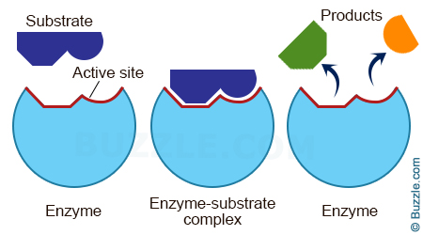

Investigate and describe the effect of changes in temperature and pH on enzyme activity

Explain the effect of changes in temperature on enzyme activity in terms of kinetic energy, shape and fit, frequency of effective collisions and denaturation
Effect of temperature on enzymes
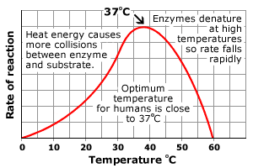
- As temperature increases, the chance of chance of substrate molecules and enzymes colliding also increases, so the rate of reaction goes up.
- This continues to an optimum (best) temperature for an enzyme. For most human enzymes the optimum temperature is 37ºC (body temperature).
- Above this temperature, the bonds holding the enzyme together start to break so it changes shape
- This deforms the active site, so enzyme and substrate cannot fit together – the enzyme has been denatured. Most enzymes denature above 50ºC.

Explain the effect of changes in pH on enzyme activity in terms of shape and fit and denaturation

Effect of pH on enzymes

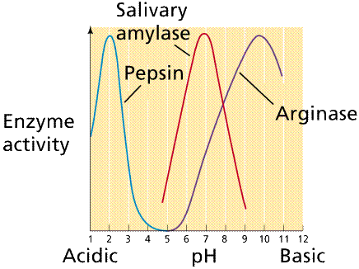

- The pH of a solution is how acidic or alkaline it is.
- Most human enzymes have an optimum pH of 7 (neutral). Some exceptions:
Pepsin, a protease in the stomach has an acidic optimum (pH2);
Lipase in the duodenum has an alkaline optimum (pH 9)
Salivary amylase in the mouth prefers a slightly-acidic pH of 6.8.
- Extreme of pH affect the shape of enzymes, denaturing them.

