Topic 14. COORDINATION & RESPONSE
14.1 Nervous control in humans

Describe a nerve impulse - an electrical signal that passes along nerve cells called neurones

Describe the human nervous system in terms of:
– the central nervous system consisting of brain and spinal cord
– the peripheral nervous system
– coordination and regulation of body functions

- The human nervous system is made of two parts-central nervous system (CNS) and peripheral nervous system(PNS);
- CNS - brain and spinal cord, which have the role of coordination;
- PNS - nerves, which connect all parts of the body to the CNS;
- Sense organs are linked to the PNS; they contain groups of receptor cells;
- When exposed to a stimulus they generate an electrical impulse, which passes along peripheral nerves to the CNS, triggering a response.
- Peripheral nerves contain sensory and motor neurons;
- Sensory neurons transmit nerve impulses from sense organs to the central nervous system;
- Motor neurons transmit nerve impulses from the CNS to effectors (muscles or glands)

Distinguish between voluntary and involuntary actions

Identify motor (effector), relay (connector) and sensory neurones from diagrams

- Neurons are covered with a myelin sheath, which insulates them to make transmission of the impulse more efficient;
- Relay neurons pick up messages from other neurons and pass them on to other neurons.
- The cytoplasm (mainly axon and dendron) is elongated to transmit the impulse for long distances.
COMPARISON OF MOTOR AND SENSORY NEURON
Structure | Sensory neuron | Motor neuron
1.Cell body | Near end of the neuron, just outside the spinal cord | At start of neuron, inside the spinal cord
2.Dendrites | Present at the end of neuron | Attached to cell body and inside the spinal cord
3. Axon (takes impulses away from cell body) | Very short stretch into spinal cord | Very long, stretches from spinal cord into a muscle
4. Dendron | Very long stretches to a receptor | None
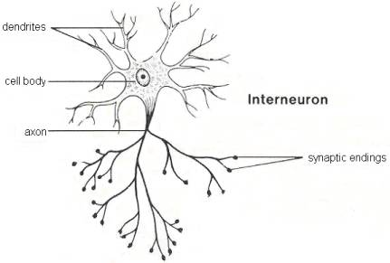
Relay neuron
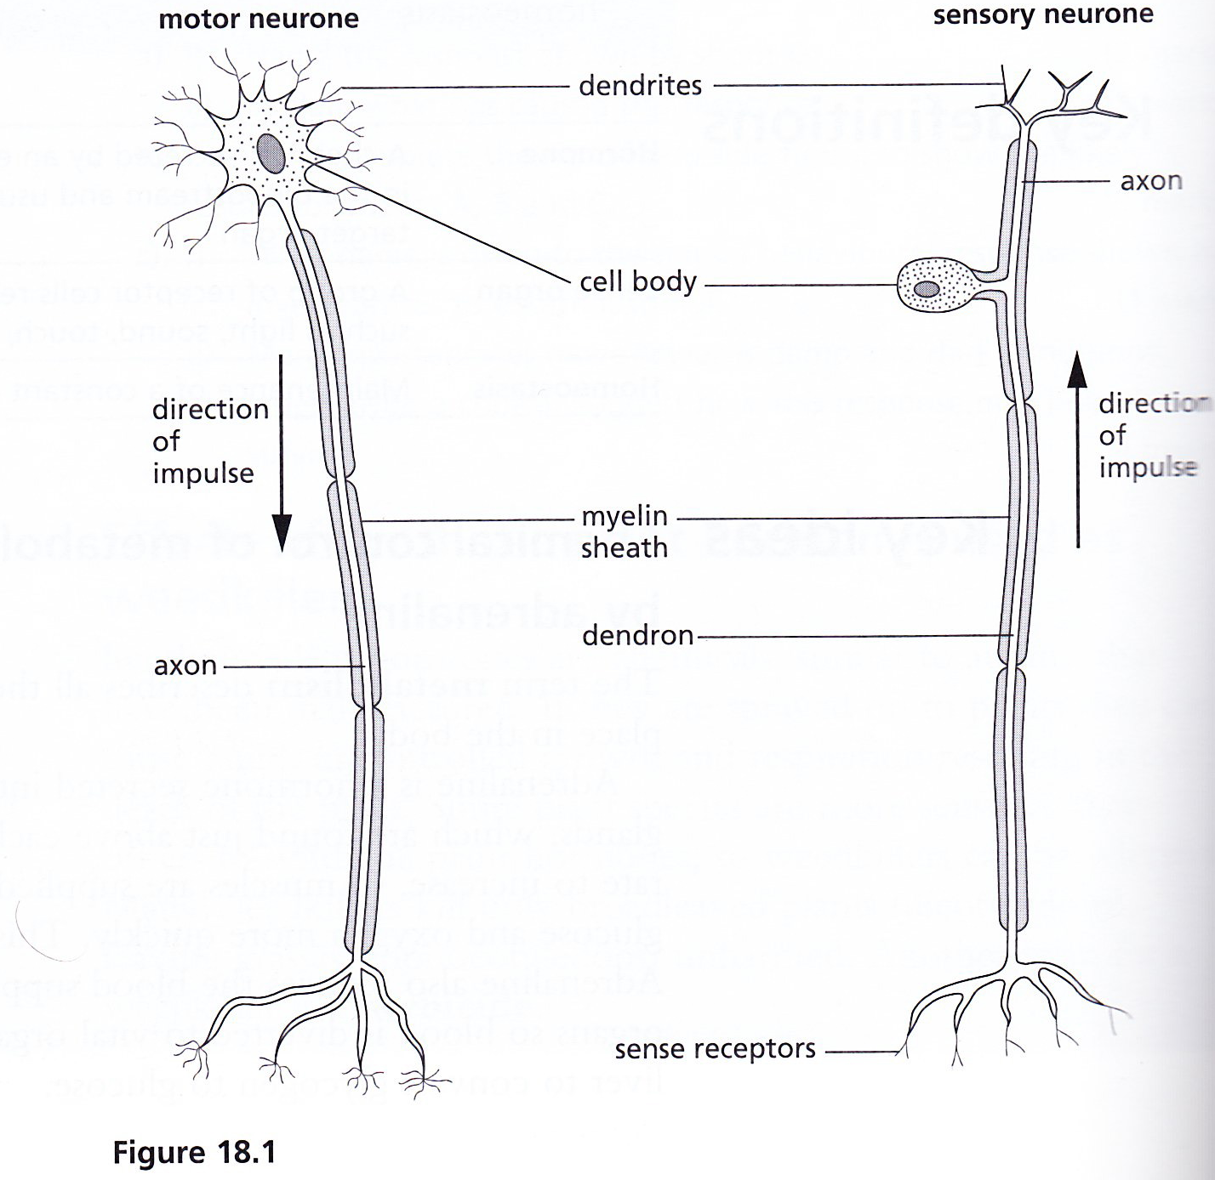

Describe a simple reflex arc in terms of receptor, sensory neurone, relay neurone, motor neurones and effector

- A reflex action is a fast, automatic response to a stimulus;

REFLEX ARC
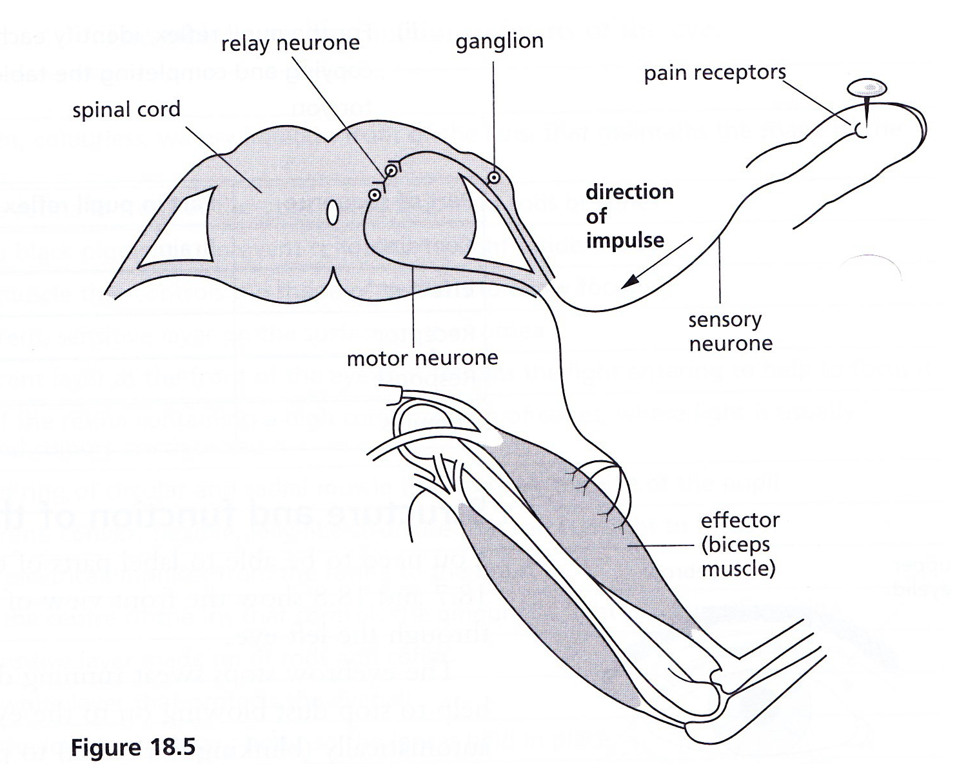
- A reflex arc describes the pathway of an electrical impulse in response to a stimulus;
- In diagram above, the stimulus is a pin sticking in the finger;
- The response is the withdrawal of the arm due to contraction of the biceps;
- Relay neurons are found in the spinal cord, connecting sensory neurons to motor neurons;
- Neurons do not connect directly with each other: there is a gap called a synapse.
- The sequence of events is
Stimulus (sharp pin in finger)

Receptor (pain receptors in skin)

Coordinator (spinal cord)

Effector (biceps muscle)

Response (biceps muscle contracts, hand is withdrawn from pin

Describe a reflex action as a means of automatically and rapidly integrating and coordinating stimuli with the responses of effectors (muscles and glands)

Define a synapse - a junction between two neurones

Describe the structure of a synapse, including the presence of neurotransmitter containing vesicles, the synaptic cleft and neurotransmitter receptor molecules

Describe how an impulse triggers the release of a neurotransmitter from vesicles into the synaptic gap and how the neurotransmitter diffuses across to bind with receptor molecules, in the membrane of the neurone after the synaptic gap, causing the impulse to continue

State that in a reflex arc the synapses ensure that impulses travel in one direction only

State that many drugs, e.g. heroin act upon synapses

