14.2 Sense Organs

Define sense organs - groups of receptor cells responding to specific stimuli: light, sound, touch, temperature and chemicals

Identify the structures of the eye, limited to cornea, iris, pupil, lens, retina, optic nerve and blind spot. Describe the function of each part of the eye, limited to cornea, iris, lens, retina, optic nerve.
Identify the position of the fovea.
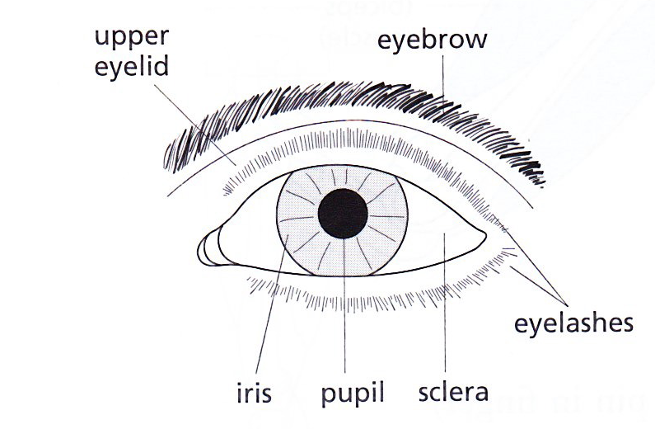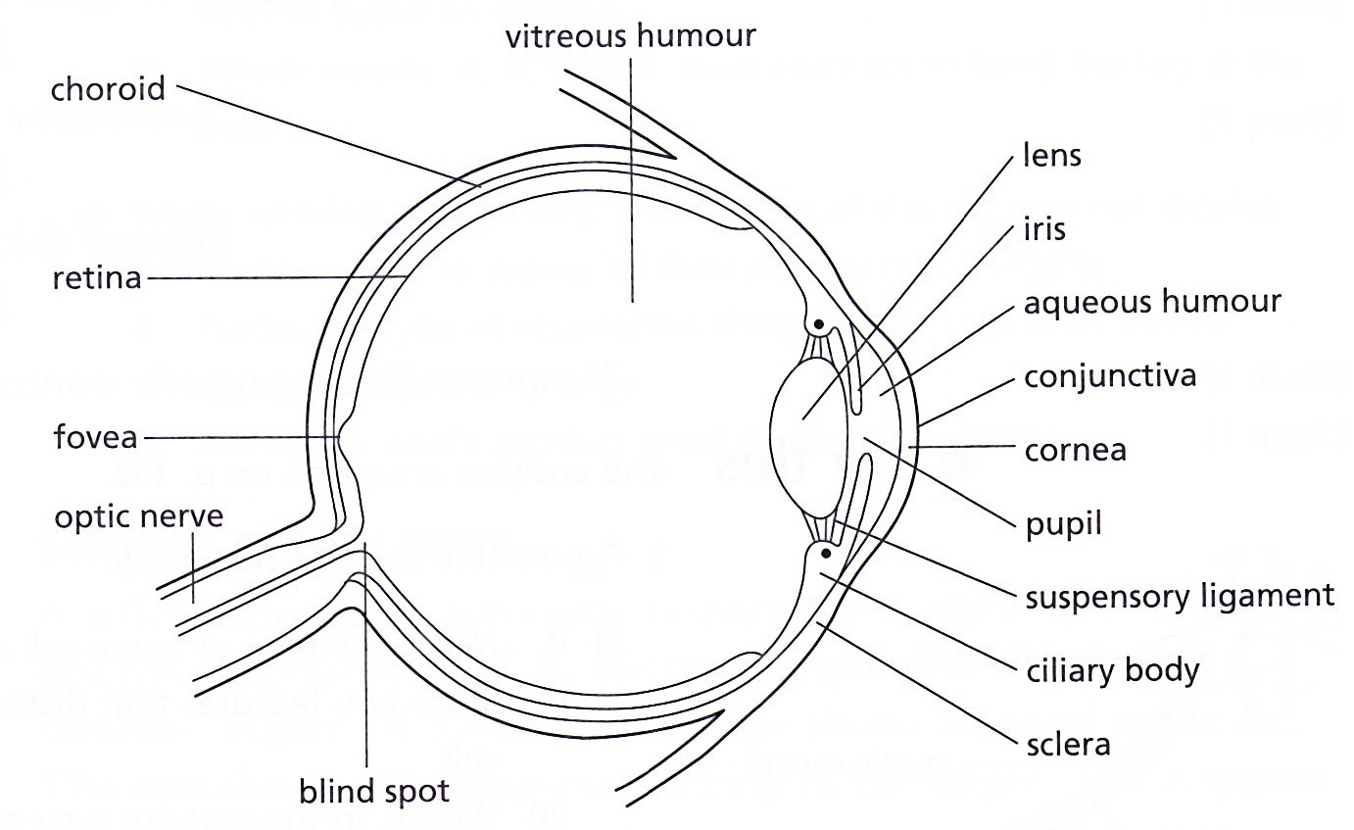
Front view Section through the eye

Part of the eye | Function
Fovea | An area of the retina containing a high concentration of cones, where light is usually focused and colours are detected
Blind spot | Part of the retina in front of the optic nerve that lacks rods or cones
Optic nerve | Transmits electrical impulses from the retina to the brain
Retina | A light sensitive layer made of rods and cones
Ciliary body | A ring of muscle that controls the shape of the lens to allow focusing
Suspensory ligament | Attaches the lens to the ciliary body, so the lens is held in place
Cornea | A transparent layer at the front of the eye that refracts the light entering to help to focus it
Iris | A coloured ring of circular and radial muscle that controls the size of the pupil
Lens | A transparent, convex, flexible, jelly-like structure that focuses light onto the retina
Pupil | A hole in the centre of the iris that controls the amount of light reaching the retina

Explain the pupil reflex in terms of light intensity and antagonistic action of circular and radial muscles in the iris
PUPIL (or iris) REFLEX (an e.g. of reflex action)
- This reflex action changes the size of the pupil to control the amount of light entering the eye
- In bright light:
- Retina detects the brightness of light entering the eye;
- An impulse passes to the brain along sensory neurons and travels back to the muscles of the iris along motor neurons, triggering a response:
- Circular muscles contract; radial muscles relax; so iris gets bigger
- Pupil constricts (gets smaller) so less light falls on the retina (to prevent damage).

- In dim light:
- Retina detects the brightness of light entering the eye;
- An impulse passes to the brain along sensory neurons and travels back to the muscles of the iris along motor neurons, triggering a response:
- Radial muscles contract; circular muscles relax; so iris gets smaller
- Pupil size is increased (dilated) to allow as much light as possible to enter the eye;

Explain accommodation to view near and distant objects in terms of the contraction and relaxation of the ciliary muscles, tension in the suspensory ligaments, shape of the lens and refraction of light
ACCOMMODATION
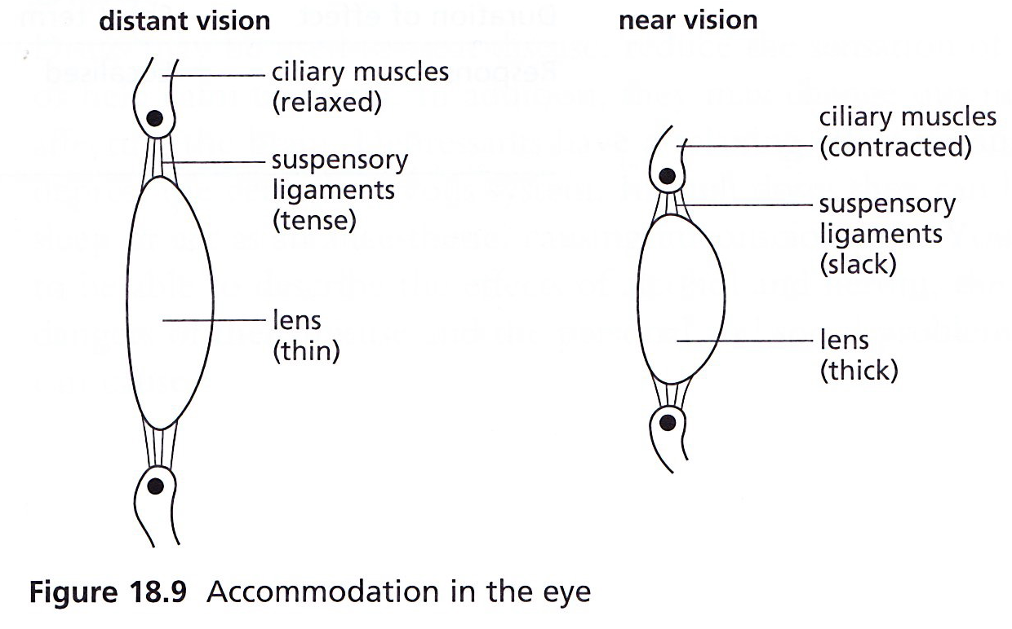

To focus on a distant object | To focus on a nearby object
Slightly diverging rays of light enter the eye | Greatly diverging rays enter the eye
Ciliary muscles relax | Ciliary muscles contract
Suspensory ligaments are pulled tight | Suspensory ligaments slacken (loosen)
Lens becomes thin | Lens get fatter
The thin lens bends the light rays slightly | The thick lens bends the light rays greatly

State the distribution of rods and cones in the retina of a human

Rods | Sensitive to dim light, do not respond to colour
Cones | Function when the light is bright, able to distinguish between different colours of light

Outline the function of rods and cones, limited to greater sensitivity of rods for night vision and three different kinds of cones absorbing light of different colours for colour vision

