14.5 Tropic responses

Define gravitropism - a response in which parts of a plant grow towards or away from gravity

Define phototropism - a response in which parts of a plant grow towards or away from the direction from which light is coming

Investigate gravitropism and phototropism in shoots and roots

Phototropism Investigation:
IGCSE Biology (Jones & Jones), p. 139, Activity 10.5 ‘To find out how shoots respond to light’.

Geotropism Investigation: IGCSE Biology (Jones & Jones), p. 140, Activity 10.6 ‘To find out how roots respond to gravity’.

Explain phototropism and gravitropism of a shoot as examples of the chemical control of plant growth. Explain the role of auxin in controlling shoot growth, limited to:
– auxin made in shoot tip (only)
– auxin spreads through the plant from the shoot tip
– auxin is unequally distributed in response to light and gravity
– auxin stimulates cell elongation

Control of plant growth by auxins
- Auxins are growth hormones;
- They are produced by the shoot and root tips of growing plants;
- An accumulation of auxin in a shoot stimulates cell growth by the absorption of water;
- However, auxins have the opposite effect in roots, when they build up, they slow down cell growth
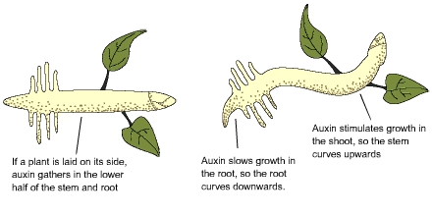
Role of auxins in phototropism and geotropism
Phototropism:
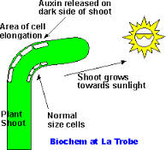
- When a shoot is exposed to light from one side, auxins produced from the shoot tip towards the shaded side of the shoot;
- Cells on shaded side stimulated to absorb more water than those on the light side;
- Thus unequal growth causes the stem to bend towards light;
- This is called positive phototropism.
- If a root is exposed to light in the absence of gravity, auxins produced by the root tip moves towards the shaded side of the root;
- Cells on the shaded side are stimulated to absorb less water than those on the light side;
- Thus unequal growth causes the root to bend away from the light;
- This is called negative phototropism.
Geotropism
- Shoot and roots also respond to gravity;
- If a shoot is placed horizontally in the absence of light, auxins accumulate on the lower side of the shoot, due to gravity;
- This makes the cells on the lower side grow more quickly than on the upper side, so the shoot bends upwards - negative geotropism;
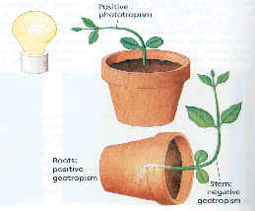

- If a root is placed horizontally in the absence of light, auxins accumulate on the lower side of the root, due to gravity;
- Thus the cells on the lower side grow more slowly than those on the upper side, so the root bends downwards - positive phototropism.

Describe the use in weedkillers of the synthetic plant hormone 2,4-D

