16.3 Sexual reproduction in Plants

Identify and draw, using a hand lens if necessary, the sepals, petals, stamens, filaments and anthers, carpels, style, stigma, ovary and ovules, of an insect-pollinated flower
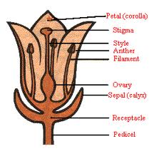
State the functions of the sepals, petals, anthers, stigmas and ovaries

Part | Function
Petal | Often large and coloured, to attract insects
Sepal | Protects the flower while in bud
Petiole (stalk) | Supports the flower to make it easily seen by insects, and to be able to withstand wind
Stamen | The male reproductive part of the flower, made of anther and filament
Anther | Contains pollen sacs, in which pollen grains are formed. Pollen contains male sex cells
Filament | Supports the anther
Carpel | The female reproductive part of the flower, made of stigma, style and ovary
Stigma | A sticky surface that receives pollen during pollination
Style | Links the stigma to the ovary, through which pollen tubes grow
Ovary | Contains ovules, which develop into seeds when fertilised

Use a hand lens to identify and describe the anthers and stigmas of a wind-pollinated flower

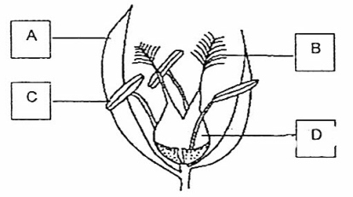
Figure showing wind-pollinated flower
A-Bract,
B-Feathery stigma,
C-Anther loosely attached to the filament, D- Ovary

Distinguish between the pollen grains of insect-pollinated and wind-pollinated flowers

Pollen grains from an insect pollinated flower

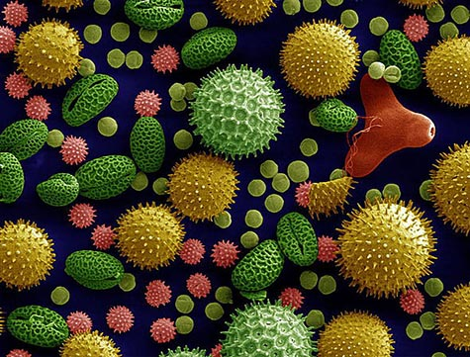

Define pollination - the transfer of pollen grains from the anther to the stigma

Define self-pollination - the transfer of pollen grains from the anther of a flower to the stigma of the same flower or different flower on the same plant

Define cross-pollination - transfer of pollen grains from the anther of a flower to the stigma of a flower on a different plant of the same species

Discuss the implications to a species of self-pollination and cross-pollination in terms of variation, capacity to respond to changes in the environment and reliance on pollinators

Describe the structural adaptations of insect-pollinated and wind-pollinated flowers

Feature | Insect-pollinated | Wind-pollinated
Petals | Present- often large, coloured and scented | Absent or small and inconspicuous
Nectar | Produced by nectaries to attract insects | Absent, or small and green
Stamen | Present inside the flower | Long filaments, allowing the anthers to hang freely outside the flower so the pollen is exposed to the wind
Stigmas | Small surface area, inside the flower | Large and feathery, hanging outside the flower to catch pollen
Pollen | Smaller amounts- grains are often round and sticky, or covered in spikes to attach to the furry bodies of insects | Larger amounts of smooth and light pollen grains, which are easily carried by the wind
Bracts (modified leaves) | Absent | Sometimes present

State that fertilisation occurs when a pollen nucleus fuses with a nucleus in an ovule

Describe the growth of the pollen tube and its entry into the ovule followed by fertilisation (details of production of endosperm and development are not required)

Investigate and state the environmental conditions that affect germination of seeds, limited to the requirement for water, oxygen and a suitable temperature
IGCSE Biology (Jones & Jones), p.190, activity 13.4 – ‘to find the conditions necessary for the germination of tomato seeds’.
Environmental conditions affecting germination

Environmental condition | Explanation
Water | Absorbed through micropyle, needed to activate enzymes which convert insoluble food stores into soluble foods needed for growth and energy production.
Oxygen | Needed for respiration, to release energy for growth and chemical changes for mobilization of food reserves
Suitable temperature | For enzymes to work as enzymes work best at optimum temperature
Light | Not usually a requirement for germination but some seeds need a period of exposure to light before they germinate

