16.4 Sexual reproduction in humans

Identify and name on diagrams of the male reproductive system: the testes, scrotum, sperm ducts, prostate gland, urethra and penis, and state the functions of these parts
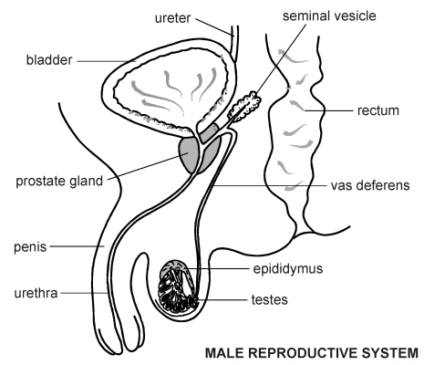

Part | Function
Epididymis | A mass of tubes in which sperm are stored
Penis | Can become firm, to insert into the vagina of the female during sexual intercourse, to transfer sperm
Prostate gland | Adds fluid and nutrients to sperm, to form semen
Scrotum | A sac that holds the testes outside the body, keeping them cooler than body temperature
Seminal vesicle | Adds fluid and nutrients to sperm, to form semen
Sperm duct | Muscular tube which links the testis to the urethra to allow the passage of semen containing sperm
Testis (pl. testes) | Male gonads that produce sperm
Urethra | To pass semen containing sperm through the penis, also carries urine from the bladder at different times

Identify and name on diagrams of the female reproductive system: the ovaries, oviducts, uterus, cervix and vagina, and state the functions of these parts
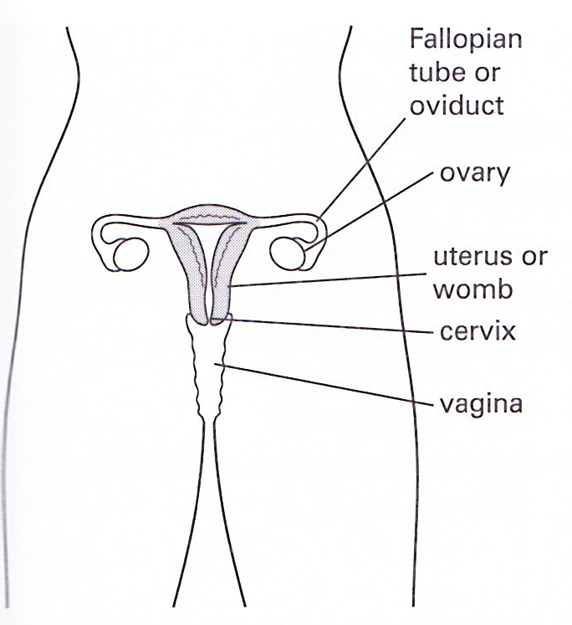
Part | Function
Cervix | A ring of muscle that separates the vagina from the uterus
Funnel of oviduct | Directs an ovum (egg) from the ovary into the oviduct
Ovary | Contains follicles in which ova (eggs) are produced
Oviduct | Carries an ovum to the uterus, with propulsion provided by tiny cilia in the wall; also the site of fertilization
Urethra | Carries urine from the bladder
Uterus | Where the fetus develops
Vagina | Receives the male penis during sexual intercourse; sperm are deposited here

Describe fertilisation as the fusion of the nuclei from a male gamete (sperm) and a female gamete (egg cell/ovum)
- During sexual intercourse, erect penis is inserted into vagina;
- Semen is ejaculated into the neck of vagina;
- Many sperms cluster around ovum but only one penetrates;
- A fertilization membrane is secreted around the egg once one sperm enters;
- The sperm nucleus fuses with egg nucleus to form zygote, this process is called fertilization.
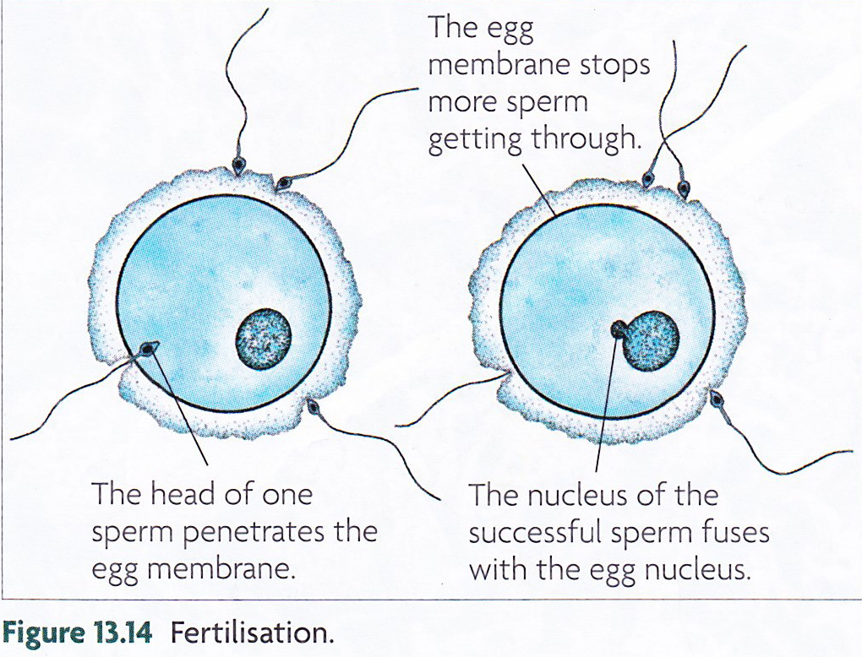

Explain the adaptive features of sperm, limited to flagellum, mitochondria and enzymes in the acrosome
State the adaptive features of egg cells, limited to energy stores and a jelly coating that changes after fertilisation
Compare male and female gametes in terms of size, structure, motility and numbers

Types of gamete | Structure
Egg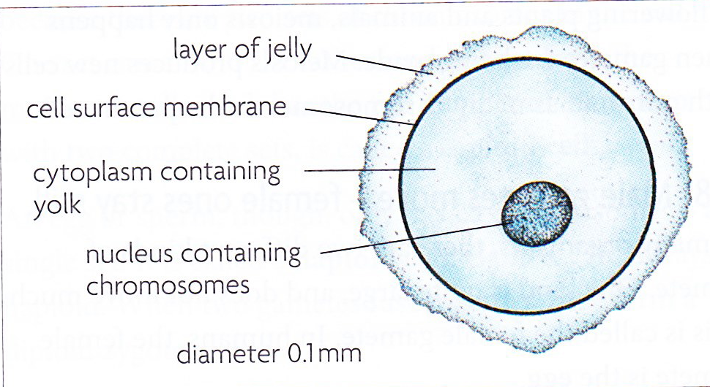 | - Is large in size 0.1mm because it has all cell components that is needed for the cell to grow and multiply; has yolk to nourish the embryo.  - During ovulation, only one egg is released every month.  - Ovum is immobile as the sperm moves towards it to fertilise it.
Sperm  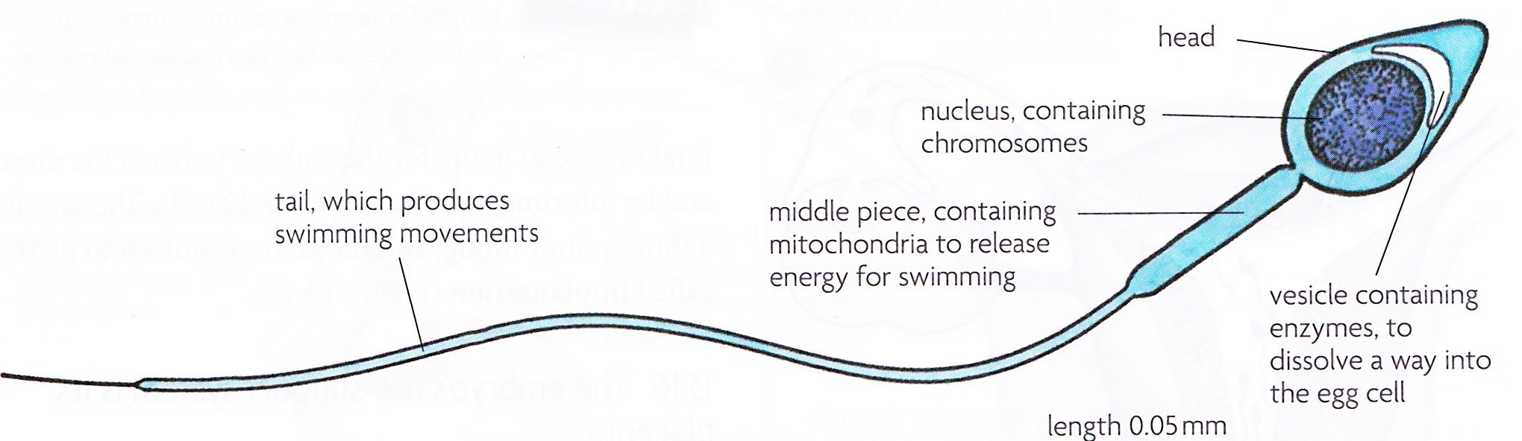 | - Size is very small 0.05mm.  - During ejaculation millions of sperms are produced into the women’s vagina.  - Sperms are highly mobile and can swim towards the oviduct with he help of its tail.

State that in early development, the zygote forms an embryo which is a ball of cells that implants into the wall of the uterus

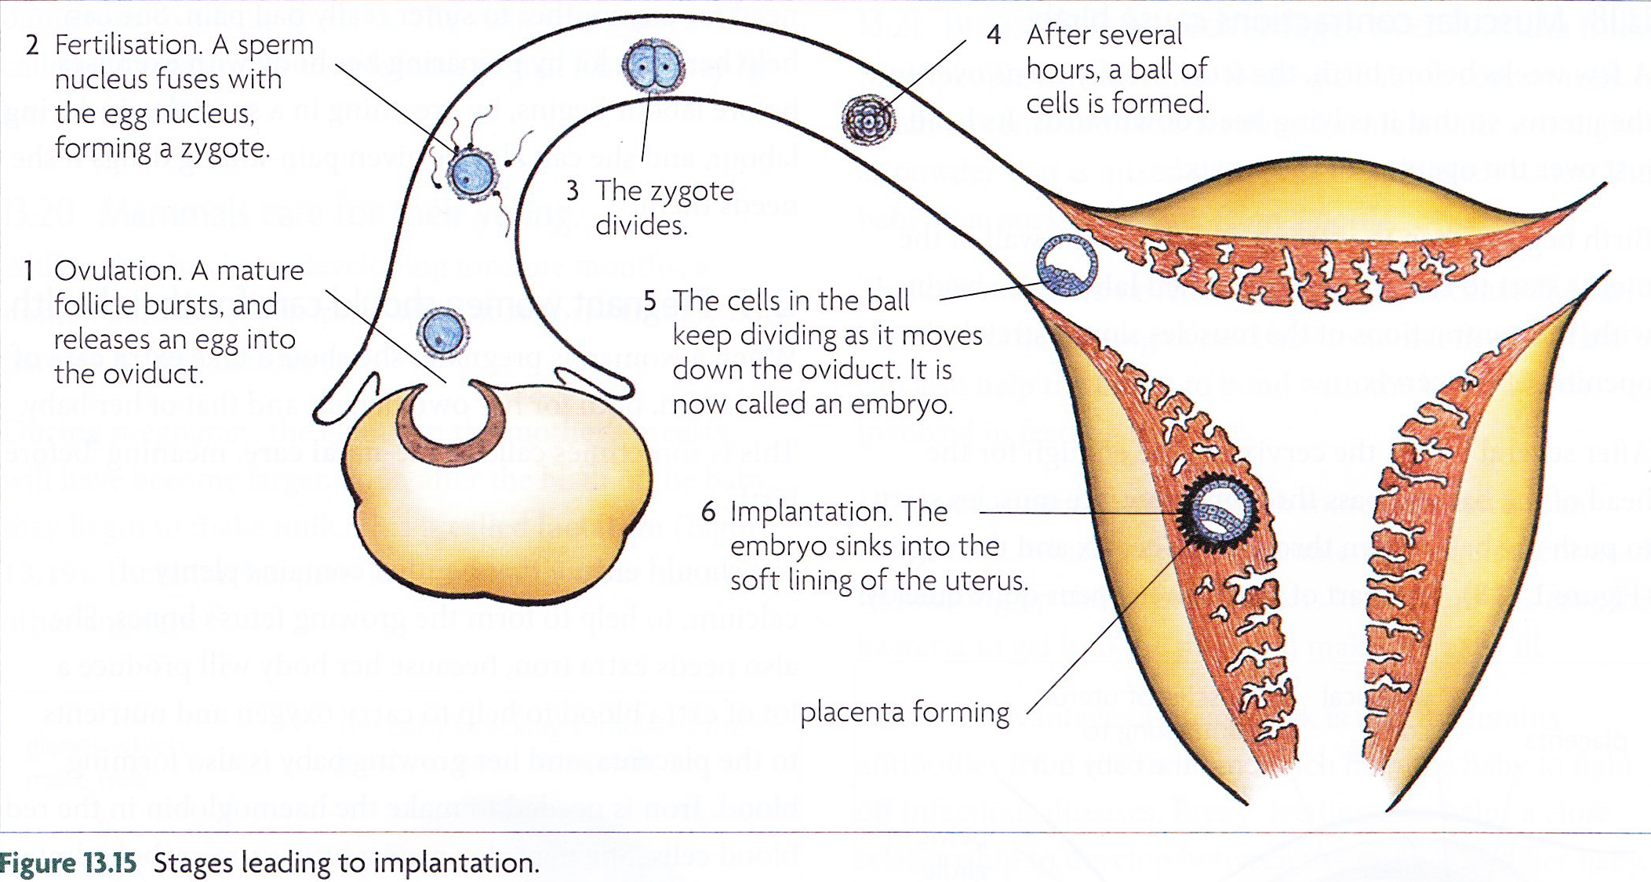

Outline the growth and development of the fetus in terms of increasing complexity in the early stages and increasing size towards the end of pregnancy

State the functions of the umbilical cord, placenta, amniotic sac and amniotic fluid

Structure | Function
Amniotic sac | A thin membrane, formed from cells of embryo, contains the amniotic fluid;  It encloses the fetus and prevents entry of bacteria.
Amniotic fluid | Supports the fetus, protecting it from physical damage;  It absorbs excretory materials (urine) released by the fetus.

Describe the function of the placenta and umbilical cord in relation to exchange of dissolved nutrients, gases and excretory products and providing a barrier to toxins and pathogens (structural details are not required)

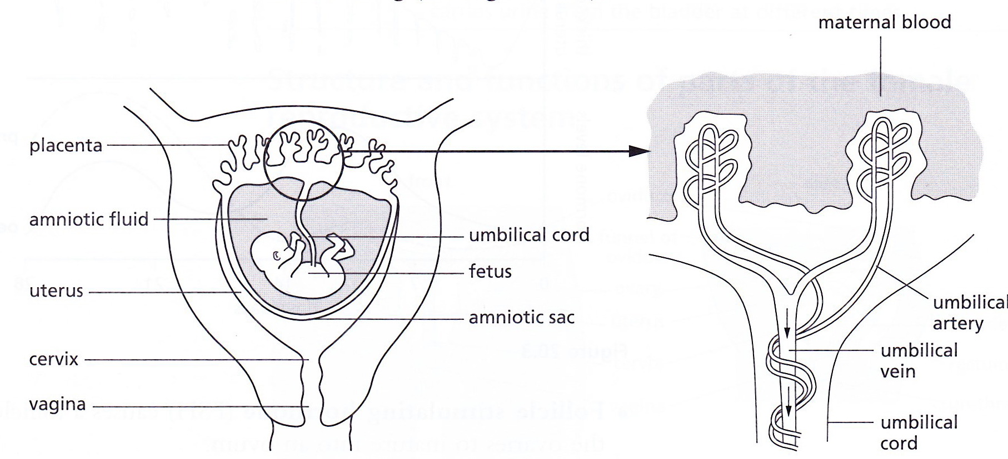
- The placenta brings the blood supply of the fetus close to that of the mother, but prevents mixing;
- This is important because the fetus and mother may have different blood groups and any mixing can result in blood clotting;
- Also the mother’s blood pressure is higher compared to the fetus which might damage the fetal organs;
- Blood from fetus passes through the umbilical cord in the umbilical artery to the placenta.
- Substances that diffuse across the placenta are as follows:

Type of substance | To fetus from mother | To mother from fetus
Respiratory gases | Oxygen | Carbon dioxide
Soluble nutrients | Amino acids, glucose, fatty acids, glycerol, vitamins, minerals, water
Disease-preventing substances | Antibodies, antibiotics
Nitrogenous excretory substances |  | Urea
Potentially harmful substances | Alcohol, nicotine and other drugs, viruses, bacteria

State that some toxins, e.g. nicotine, and pathogens, e.g. rubella virus, can pass across the placenta and affect the fetus

Describe the ante-natal care of pregnant women, limited to special dietary needs and the harm from smoking and alcohol consumption

Outline the processes involved in labour and birth, limited to:
  - breaking of the amniotic sac
  - contraction of the muscles in the uterus wall
  - dilation of the cervix
  - passage through the vagina
  - tying and cutting the umbilical cord
  - delivery of the afterbirth

Discuss the advantages and disadvantages of breast-feeding compared with bottle-feeding using formula milk

Advantages of breast-feeding over bottle-feeding:
- There are antibodies present in the breast milk, giving the baby protection against infection;
- Foodstuffs are present in breast milk in the correct proportions;
- There are no additives and preservatives in breast milk;
- Breast feeding builds a bond between mother and baby;
- Breast milk does not require sterilization as there are no bacteria present that could cause intestinal disease;
- Breastfeeding triggers a reduction in the size of the mother’s uterus.
- Formula milk is much more expensive than breast milk, which is free.
Advantages of bottle-feeding over breast-feeding:
- Someone else can feed the mother’s baby;
- This can also help the father to bond with the baby, if he is involved in feeding.

