Topic 17. Inheritance
17.1 Inheritance

Define inheritance - the transmission of genetic information from generation to generation

17.2 Chromosomes, genes & proteins

Define chromosome - a thread-like structure of DNA, carrying genetic information in the form of genes
Define gene - a length of DNA that codes for a protein
Define allele - a version of a gene
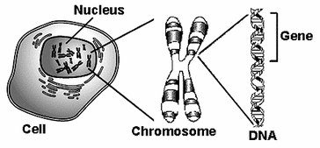

Describe the inheritance of sex in humans with reference to XX and XY chromosomes
- Of the 23 pairs of chromosomes present in each human cell, one pair is the sex chromosome;
- These determine the sex of the individual;
- Males have XY, and females have XX.
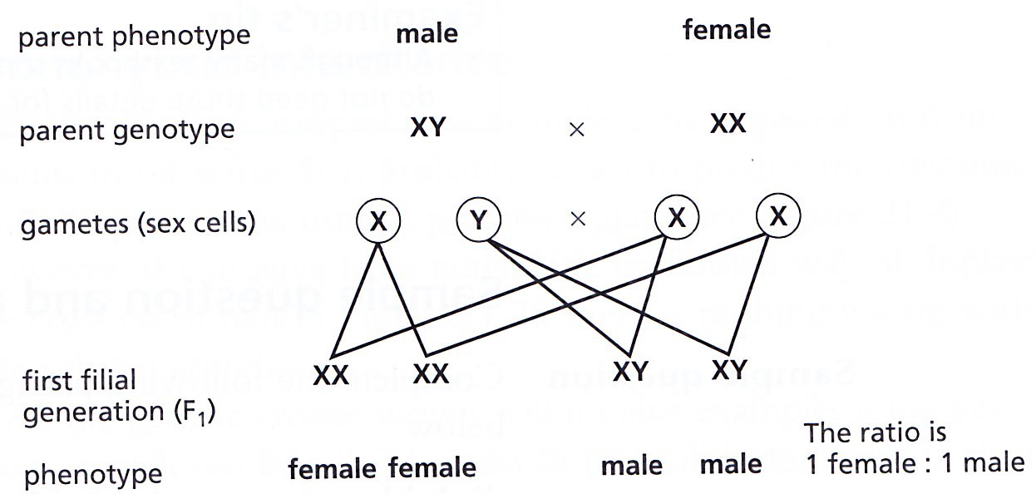

Explain that the sequence of bases in a gene is the genetic code for putting together amino acids in the correct order to make a specific protein (knowledge of the details of nucleotide structure is not required)

Explain that DNA controls cell function by controlling the production of proteins (some of which are enzymes), antibodies and receptors for neurotransmitters

Explain how a protein is made, limited to:
  - the gene coding for the protein remains in the nucleus
  - mRNA molecules carry a copy of the gene to the cytoplasm
  - the mRNA passes through ribosomes
    - the ribosome assembles amino acids into proteins
  - – the specific order of amino acids is determined by the sequence of bases in the mRNA
(knowledge of the details of transcription or translation is not required)

Explain that all body cells in an organism contain the same genes, but many genes in a particular cell are not expressed because the cell only makes the specific proteins it needs

Define a haploid nucleus - a nucleus containing a single set of unpaired chromosomes, e.g. in gametes

Define a diploid nucleus - a nucleus containing two sets of chromosomes, e.g. in body cells

State that in a diploid cell, there is a pair of each type of chromosome and in a human diploid cell there are 23 pairs

