17.3 Mitosis

Define mitosis - nuclear division giving rise to genetically identical cells
(details of stages are not required)

State the role of mitosis in growth, repair of damaged tissues, replacement of cells and asexual reproduction

State that the exact duplication of chromosomes occurs before mitosis

State that during mitosis, the copies of chromosomes separate, maintaining the chromosome number

Describe stem cells as unspecialised cells that divide by mitosis to produce daughter cells that can become specialised for specific functions

17.4 Meiosis

Define meiosis - reduction division in which the chromosome number is halved from diploid to haploid resulting in genetically different cells
(details of stages are not required)

State that meiosis is involved in the production of gametes
Gametes are the result of meiosis, which on fertilization helps to retain the chromosome number specific for a species.
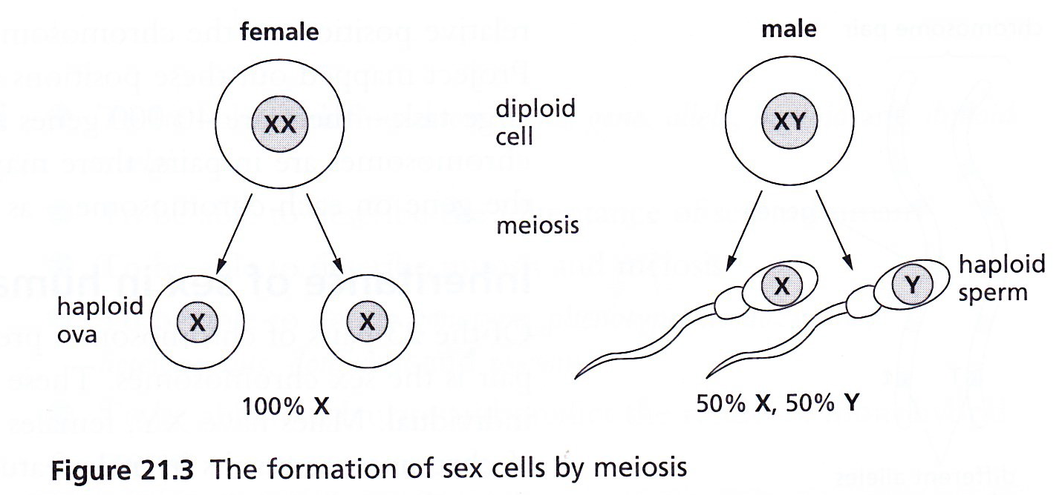

Explain how meiosis produces variation by forming new combinations of maternal and paternal chromosomes (specific details are not required)

- Sex cells are formed in the gonads (ovaries and testes) by meiosis;
- The gametes (sex cells) produced are haploid, but they are formed from diploid cells;
- Thus meiosis involves halving the normal chromosome number;
- At the end of the process, cells produced are not all identical, thus meiosis results in variation.

