17.5 Monohybrid inheritance

Define genotype - the genetic make-up of an organism in terms of the alleles present (e.g. Tt or GG).

Define phenotype - the observable features of an organism (e.g. tall plant or green seed)

Define homozygous - having two identical alleles of a particular gene (e.g. TT or gg). Two identical homozygous individuals that breed together will be pure-breeding

Define heterozygous - having two different alleles of a particular gene (e.g. Tt or Gg). A heterozygous individual will not be pure-breeding

Define dominant - an allele that is expressed if it is present (e.g. T or G)

Define recessive - an allele that is only expressed when there is no dominant allele of the gene present (e.g. t or g)

Interpret pedigree diagrams for the inheritance of a given characteristic

Use genetic diagrams to predict the results of monohybrid crosses and calculate phenotypic ratios, limited to 1:1 and 3:1 ratios.

Monohybrid inheritance involves the study of how a single gene is passed on from parents to offspring.
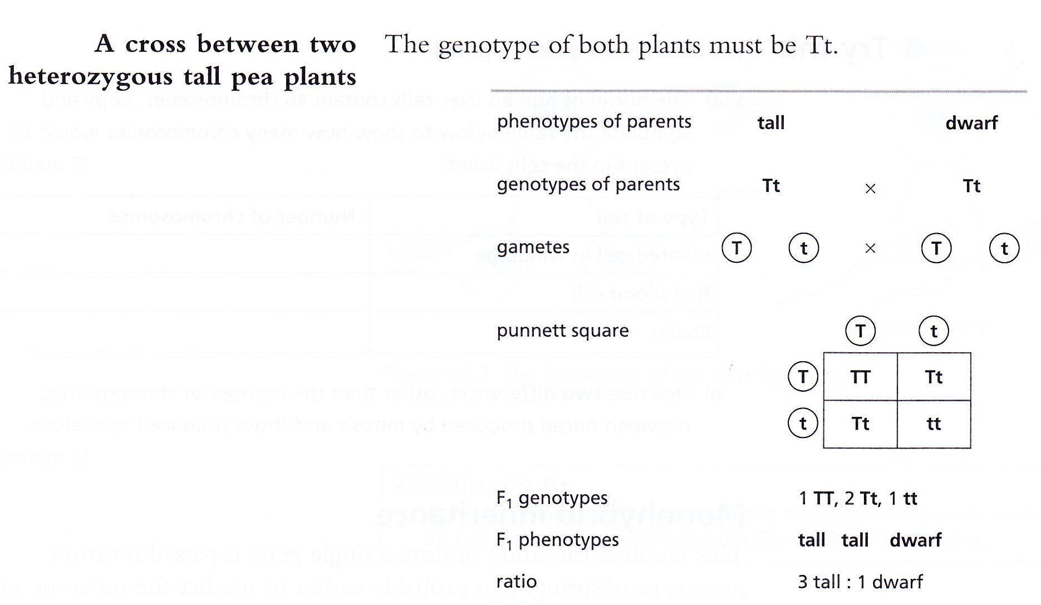

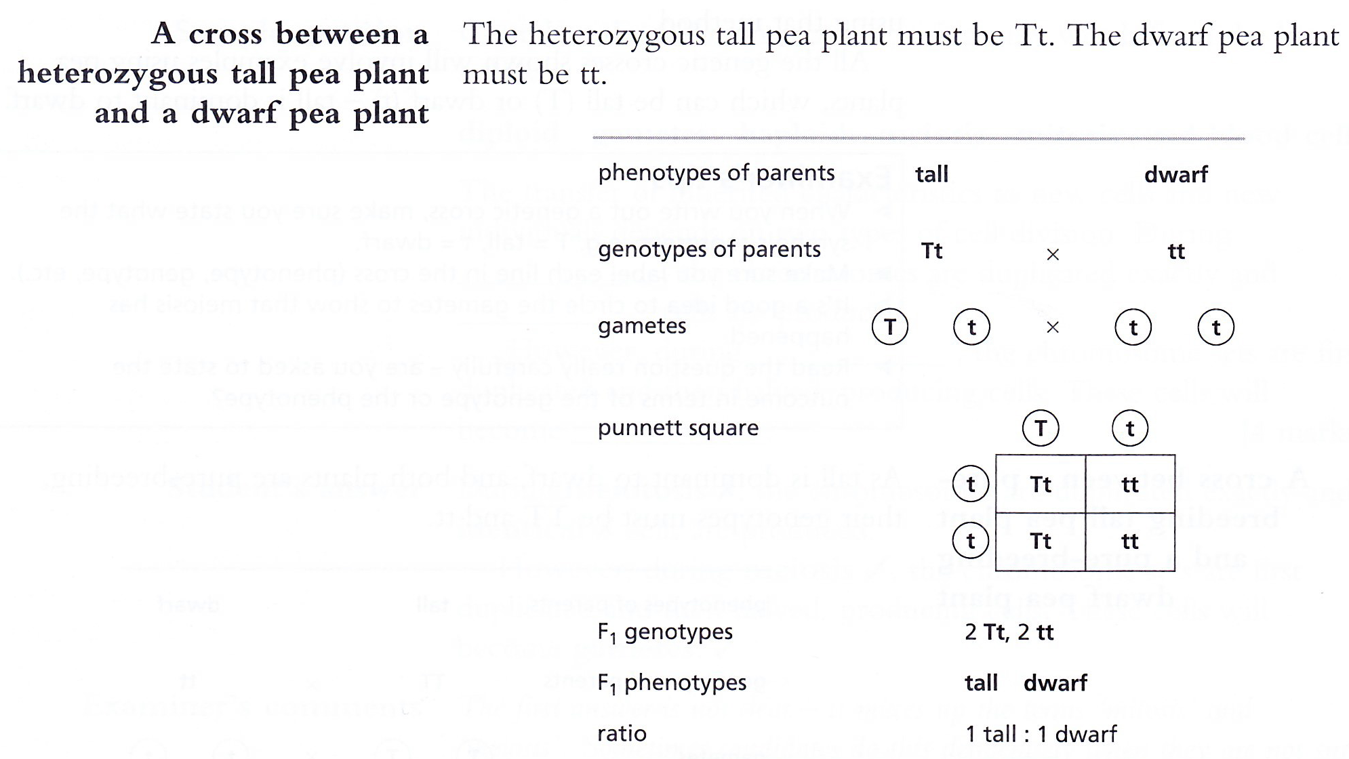

Use Punnett squares in crosses which result in more than one genotype to work out and show the possible different genotypes
As above

Explain how to use a test cross to identify an unknown genotype

Explain co-dominance by reference to the inheritance of ABO blood groups – phenotypes being A, B, AB and O blood groups and alleles being I^{A}, I^{B} and I^{O}

Define a sex-linked characteristic - a characteristic in which the gene responsible is located on a sex chromosome and that this makes it more common in one sex than in the other

Describe colour blindness as an example of sex linkage

Use genetic diagrams to predict the results of monohybrid crosses involving co-dominance or sex linkage and calculate phenotypic ratios

