Topic 11. Gas Exchange in humans

List the features of gas exchange surfaces in humans, limited to large surface area, thin surface, good blood supply and good ventilation with air

- Wall of the alveolus is thin (a single layer of cells) to allow gases to diffuse across them quickly;
- They are moist to prevent the cells from drying and to allow gases to dissolve;
- They have a large surface area , so that a lot of gas can diffuse across at the same time;
- They have a high concentration gradient - maintained by the movement of air & blood.

Name and identify the lungs, diaphragm, ribs, intercostal muscles, larynx, trachea, bronchi, bronchioles, alveoli and associated capillaries, and the internal and external intercostal muscles

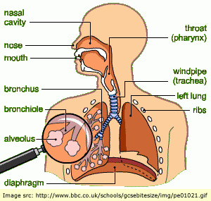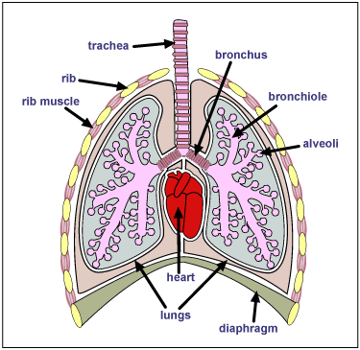

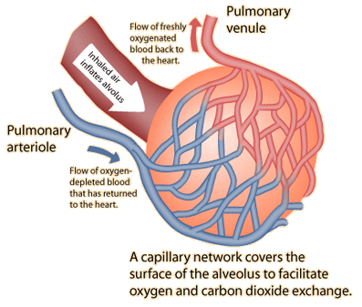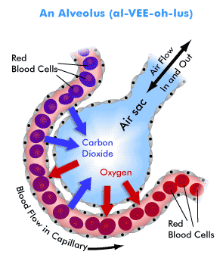

State the functions of the cartilage in the trachea

Explain the role of the ribs, the internal & external intercostal muscles and the diaphragm in producing volume and pressure changes in the thorax leading to the ventilation of the lungs

State the differences in composition between inspired and expired air (oxygen, carbon dioxide and water vapour). Explain the differences in composition between inspired and expired air

Gas | Inspired air % | Expired air % | Explanation
Nitrogen | 79 | 79 | Not used or produced by body processes
Oxygen | 21 | 16 | Used up in the process of respiration
Carbon dioxide | 0.04 | 4 | Produced in the process of respiration
Water vapour | Variable | Saturated | Produced in the process of respiration, moisture evaporates from the surface of the alveoli

Use limewater as a test for carbon dioxide to investigate the differences in composition between inspired and expired air
IGCSE Biology (Jones & Jones), p. 122, activity 9.5 ‘comparing the CO₂ content of inspired & expired air’.

Investigate and describe the effects of physical activity on rate and depth of breathing
Explain the link between physical activity and rate and depth of breathing in terms of the increased carbon dioxide concentration in the blood, detected by the brain, causing an increased rate of breathing

- The volume of air breathed in and out during normal, relaxed breathing is about 0.5 litres (the tidal volume);
- The breathing rate is about 12 breaths per minute;
- During exercise, the volume inhaled (depth) increases to about 5 litres ( depending on the age, sex, size and fitness of the person);
- The maximum amount of air breathed in and out in one breath is the vital capacity;
- The breathing rate can increase to over 20 breaths per minute;
- The total lung volume is greater than the vital capacity because some air always remains in the lungs (otherwise the lungs would collapse and the alveoli walls would stick together)
- Breathing rate and depth increase to absorb more oxygen for the muscles as exercising muscles need to respire more to get more energy.

Explain the role of goblet cells, mucus and ciliated cells in protecting the gas exchange system from pathogens and particles

Air
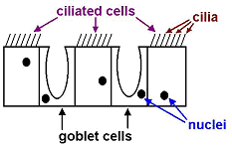Diagram of lining of trachea

- The lining contains two kinds of cells: Goblet cells and ciliated cells;
- Goblet cells make sticky, slimy mucus;
- Many of the bacteria in the air and dust particles get trapped in the mucus;
- Ciliated cells have tiny, microscopic hair on them called cilia;
- The cilia beat in unison, and sweep the mucus upwards, towards the back of the throat.

