Topic 2. Organisation of the organism

2.1 Cell Structure & Organisation

- Describe and compare the structure of a plant cell with an animal cell, as seen under a light microscope, limited to cell wall, nucleus, cytoplasm, chloroplasts, vacuoles and location of the cell membrane
- State the functions of the structures seen under the light microscope in the plant cell and in the animal cell
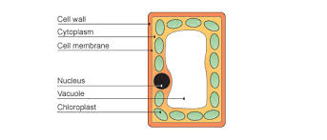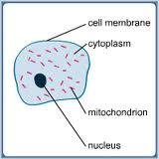
Plant cell (palisade cell) Animal Cell (liver cell)

PARTS OF A CELL

 | PART | DESCRIPTION | FUNCTION
Animal & plant cells | Cytoplasm | Jelly-like, 70% is water | Chemical reactions take place here  Contains cell organelles and ribosomes on rough endoplasmic reticulum & vesicles
 | Membrane | Surrounds the cell; partially permeable | Controls what substances enter & leave the cell.
 | Nucleus | Contains DNA in the form of chromosomes | Controls cell division;  Controls cell development;  Controls cell activities.
 | Mitochondria |  | Site of aerobic respiration
 | Rough endoplasmic reticulum |  | Has ribosomes on it
Plant cells only | Cell wall | Tough layer made of cellulose, surrounds the cell membrane | Freely permeable (allows water and salts to pass through);  Protects and supports the cell;  Prevents plant cells from bursting
 | Sap vacuole | Fluid-filled space surrounded by a membrane | Contains salts and sugars (cell sap);  Helps keep plant cells turgid (firm)
 | Chloroplast | Organelle containing chlorophyll | Chlorophyll taps light energy for photosynthesis

The differences in structure between typical animal and plant cells:

PLANT CELLS | ANIMAL CELLS
Have a cellulose cell wall outside the membrane | No cell wall
Often have chloroplasts containing chlorophyll | No chloroplasts
Often have one large vacuoles containing cell sap | Have only small vacuoles (vesicles)
Often have starch grains | Never have starch grains; sometimes have glycogen granules
Often regular in shape | Often irregular in shape

- State that the cytoplasm of all cells contains structures, limited to ribosomes on rough endoplasmic reticulum and vesicles

- State that almost all cells, except prokaryotes, have mitochondria and rough endoplasmic reticulum

- Identify mitochondria and rough endoplasmic reticulum in diagrams and images of cells

- State that aerobic respiration occurs in mitochondria

- State that cells with high rates of metabolism require large numbers of mitochondria to provide sufficient energy

2.2 Levels of organisation

- Relate the structure of the following to their functions:
– ciliated cells – movement of mucus in the trachea and bronchi
– root hair cells – absorption
– xylem vessels – conduction and support
– palisade mesophyll cells – photosynthesis
– nerve cells – conduction of impulses
– red blood cells – transport of oxygen
– sperm and egg cells – reproduction

Structure | Special features | Functions
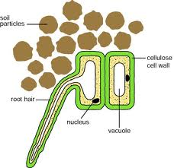 | The ‘hair’ gives a large surface area due to its elongated shape | Absorbs water and mineral ions;  Anchor the plant firmly in the soil
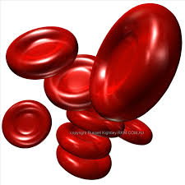 | Have no nucleus;  contain hemoglobin;  biconcave shape (for greater surface area);  flexible (so they fit through small capillaries). | Transport oxygen around the body. No nucleus so more room for oxygen bound to hemoglobin.

Define tissue - a group of cells with similar structures, working together to perform a shared function

Define organ - a structure made up of a group of tissues, working together to perform specific functions

Define organ system - a group of organs with related functions, working together to perform body functions

State examples of tissues, organs and organ systems from sections 6 to 16

Identify the different levels of organisation in drawings, diagrams and images of both familiar and unfamiliar material

2.3 Size of specimens

- Calculate magnification and size of biological specimens using millimetres and micrometres as units

Magnification (X) = Measured length (mm) ÷ Actual length (mm)

