Topic 3. Movement in & out of cells

3.1 Diffusion

Define diffusion
Diffusion is as the net movement of particles from a region of their higher concentration to a region of their lower concentration down a concentration gradient, as a result of their random movement

Describe the importance of diffusion of gases and solutes

Substance diffused | Site of diffusion
Oxygen | From the alveoli into blood capillaries
Carbon dioxide | From blood capillaries into the alveoli.  From air, through stomata & into the leaf for photosynthesis.
Soluble products of digestion | From small intestine to the blood capillaries.
Scent made of tiny molecules | From flowers into the bee’s body.

Importance of water as a solvent:
- Most cells contain about 75% of water;
- Many important metabolic reactions take place in aqueous solution;
- Many substances move around a cell dissolved in water (and also around organisms, e.g. in blood, xylem & phloem).

State that substances move into and out of cells by diffusion through the cell membrane

State that the energy for diffusion comes from the kinetic energy of random movement of molecules and ions

Investigate the factors that influence diffusion, limited to surface area, temperature, concentration gradients and distance

Factors that help diffusion are as follows:
- Distance (the shorter the better) e.g. thin walls of alveoli and the capillaries.
- Concentration gradient (the bigger the better). This can be maintained by removing the substance as it passes across the diffusion surface.
- Size of the molecules (the smaller the better).
- Surface area for diffusion (the larger the better) e.g. there is millions of alveoli in a lung, giving a huge surface area for diffusion of oxygen.
- Temperature (molecules have more kinetic energy at higher temperatures).

3.2 Osmosis

State that water diffuses through partially permeable membranes by osmosis

State that water moves in and out of cells by osmosis through the cell membrane

Define osmosis

Osmosis is the net movement of water molecules from a region of higher water potential (dilute solution) to a region of lower water potential (concentrated solution), through a partially permeable membrane

Investigate and describe the effects on plant tissues of immersing them in solutions of different concentrations

Explain the effects on plant tissues of immersing them in solutions of different concentrations by using the terms turgid, turgor pressure, plasmolysis and flaccid

Effects of osmosis on plant and animal tissues:
- When placed in pure water, plant and animal cells will take in the water by osmosis;
- This is because there is a higher concentration of water molecules outside the cell than inside it;
- Plants become turgid, but do not burst because of their tough cell wall;
- Animal cells will burst, because they have no cell wall;
- The reverse happens when plant and animal cells are placed in a concentrated sugar or salt solutions. This is because there is a higher concentration of water molecules inside the cell than outside it;
- Plant cells become flaccid and the cytoplasm is no longer pressed against the cell wall;

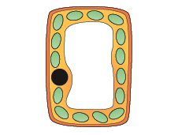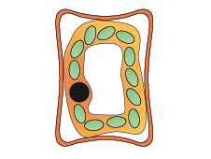
Turgid plant cell Flaccid plant cell

- Animal cells also become flaccid and their shape changes- they can become crenated.

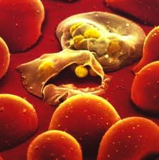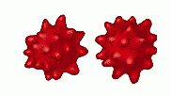
RBC burst Crenated RBC

State that plants are supported by the pressure of water inside the cells pressing outwards on the cell wall

Explain how plants are supported by the turgor pressure within cells, in terms of water pressure acting against an inelastic cell wall

Explain the importance of water potential and osmosis in the uptake of water by plants

Importance of osmosis in the uptake of water by plants:
- Usually, the water in the soil is more dilute than that in root hair cells
- So water enters root hair cells by osmosis (a passive process – requiring no energy)

- Water potential is the correct term for saying ”water concentration” a high water potential is equivalent to a low solute concentration and vice versa;
- For plants to take in water through their roots they must have a high solute concentration or low water potential in the roots and low solute concentration or high water potential outside the roots.
- In osmosis, water molecules diffuse down a water potential gradient.

Explain the importance of water potential and osmosis on animal cells and tissues

3.3 Active Transport

Define active transport - the movement of particles through a cell membrane from a region of lower concentration to a region of higher concentration using energy from respiration

Discuss the importance of active transport as a process for movement across membranes:
– e.g. ion uptake by root hairs & uptake of glucose by epithelial cells of villi & kidney tubules

Explain how protein molecules move particles across a membrane during active transport

