Topic 4. Biological molecules

- List the chemical elements that make up carbohydrates, fats and proteins

NUTRIENT | ELEMENTS PRESENT
Carbohydrate | Carbon, hydrogen, oxygen
Fat | Carbon, hydrogen, oxygen
Protein | Carbon, hydrogen, oxygen, nitrogen and sometimes sulphur

- State that large molecules are made from smaller molecules, limited to:
  - starch and glycogen from glucose
  - cellulose from glucose
  - proteins from amino acids
  - fats and oils from fatty acids and glycerol

Many large biological molecules are long chains of smaller units held together by chemical bonds

LARGE MOLECULE | STRUCTURE | SMALLER BASIC UNIT
Large (complex) CARBOHYDRATES  Starch,  Glycogen,  Cellulose | 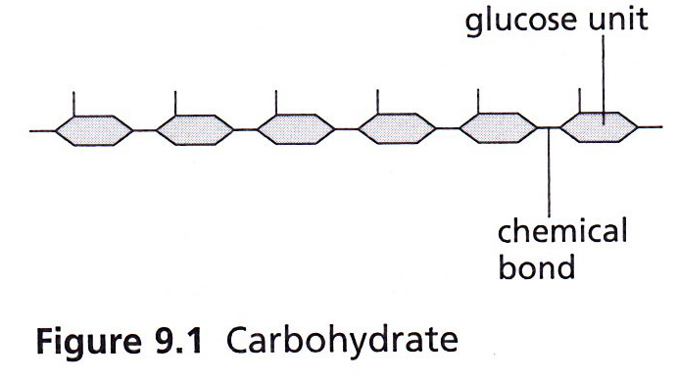 | Monosaccharides (sugars) such as glucose
LIPIDS  Fats & oils | 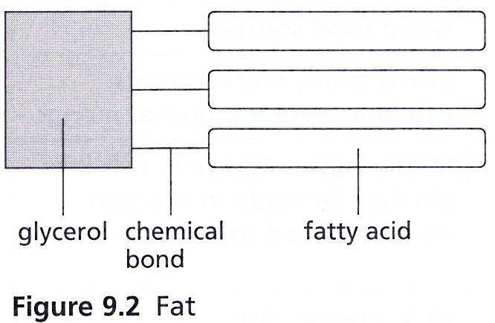 | 3 fatty acids chemically bonded to 1 glycerol
PROTEINS | 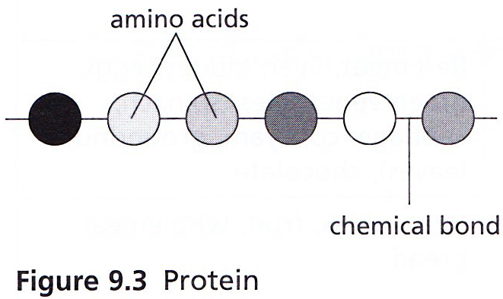 | Amino acids

- Describe the use of:
– iodine solution to test for starch
– Benedict’s solution to test for reducing sugars
– biuret test for proteins
– ethanol emulsion test for fats and oils
– DCPIP test for vitamin C

Food tested | Name of test | Method | Positive result
Starch | Starch test | Add a few drops of iodine solution (brown) to a solution of the food. | Blue/black
Reducing sugars e. g. glucose | Benedict’s test | Add an equal amount of Benedict’s solution (light blue) to a solution of the food.  Boil carefully. | Blue green orange brick red
Protein | Biuret test | Add Biuret solution (light blue) to the solution of food. | Violet
Fats & oils | Emulsion test | Dissolve the food in ethanol. Pour the solution into a clean test tube of water. | White emulsion
Vitamin C | DCPIP test | Add DCPIP solution (blue) to a solution of the food. | Colourless

- Explain that different sequences of amino acids give different shapes to protein molecules

- Relate the shape and structure of protein molecules to their function, limited to the active site of enzymes and the binding site of antibodies

- State that water is important as a solvent

- Describe the roles of water as a solvent in organisms with respect to digestion, excretion and transport

- Describe the structure of DNA as:
– two strands coiled together to form a double helix
– each strand contains chemicals called bases
– cross-links between the strands are formed by pairs of bases
– the bases always pair up in the same way: A with T, and C with G
(full names are not required)

