Topic 8. Transport in Plants

8.1 Transport in Plants

State the functions of xylem and phloem

- Xylem transports water in plants and help to support them.
- Phloem transports sucrose and other substances in plants

Identify the position of xylem and phloem as seen in sections of roots, stems and leaves, limited to non-woody dicotyledonous plants

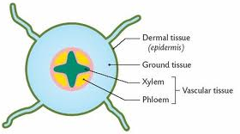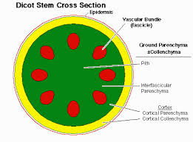
T.S of a root T.S of a stem
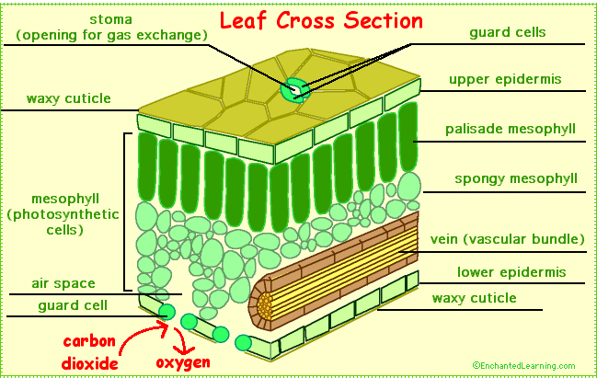
T.S of a leaf

8.2 Water uptake

Identify root hair cells, as seen under the light microscope, and state their functions

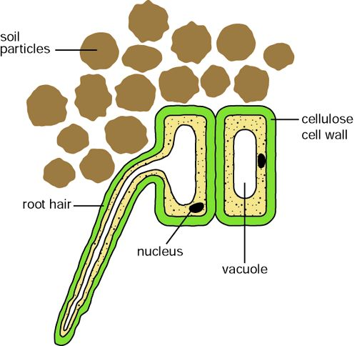
Functions:
- Increases the surface area of the root for absorption of water and mineral ions.
- Provides anchorage for the plant.

Explain that the large surface area of root hairs increases the rate of the absorption of water by osmosis and ions by active transport

- Each root hair is a long epidermal cell, this increases the surface area for absorption;
- Root hairs are long & thin and so can penetrate between the smallest soil particles for absorption.

State the pathway taken by water through root, stem and leaf as root hair cell, root cortex cells, xylem and mesophyll cells

Root hair Root cortex cells xylem of root xylem of stem xylem of leaf mesophyll cells
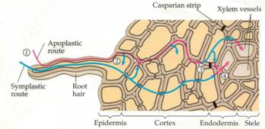

Investigate, using a suitable stain, the pathway of water through the above ground parts of a plant

IGCSE Biology (Jones & Jones), p. 105, activity 8.2 ‘to see which part of a stem transports water & solutes’.

8.3 Transpiration

State that water is transported from the roots to leaves through the xylem vessels

Define transpiration - the loss of water vapour from plant leaves by evaporation of water at the surfaces of the mesophyll cells followed by diffusion of water vapour through the stomata

Explain how water vapour loss is related to the large surface area of cell surfaces, interconnecting air spaces and stomata

- Transpiration is the loss of water vapour from the leaf;
- Water in the mesophyll cells form a thin layer on their surfaces;
- The water evaporates into the air spaces in the spongy mesophyll;
- This creates a high concentration of water molecules in the air spaces.
- Water vapour diffuses out of the leaf into the surrounding air, through the stomata, by diffusion.

Explain the mechanism by which water moves upwards in the xylem in terms of a transpiration pull that draws up a column of water molecules, held together by cohesion

- Mechanism of water uptake
- Water enters root hair cells by osmosis (as the water potential in the soil surrounding the root is higher than in the cell);
- As the water enters the cell, its water potential becomes higher than in the cell next to it, e.g. in the cortex;
- So the water moves by osmosis, into the next cell;
- This process is repeated until water reaches the xylem.
- Mechanism of water movement through a plant
- Transpiration continuously removes water from the leaf;
- Thus water is constantly being taken from the top of the xylem vessels, to supply the cells in the leaves;
- This reduces the effective pressure at the top of the xylem vessels;
- This creates a transpiration stream or ‘pull’, pulling water up;
- Water molecules have a strong tendency to stick together. This is called cohesion;
- When the water is ‘pulled’ up the xylem vessels, the whole column of water stays together;
- Roots also produce a root pressure, forcing water up the xylem vessels.

Explain how and why wilting occurs

Explain the effects of variation of temperature and humidity on transpiration rate

The table below shows the factors that can result in an increase in the rate of transpiration.
(If these factors are reversed, the rate will decrease).

FACTOR | EXPLANATION
Increase in temperature | Increases the kinetic energy of the water molecules, so they diffuse faster
Increase in air movement e.g. wind | Removes water molecules as they pass out of the leaf, maintaining a steep concentration gradient for diffusion
Decrease in humidity | Results in lower concentration of water molecules outside the leaf, making a steeper concentration gradient for diffusion
Increase in light intensity | Stomata open to allow gas exchange for photosynthesis , so water vapour can diffuse out of the leaf

Investigate and describe the effects of variation of temperature and humidity on transpiration rate

8.4 Translocation

Define translocation – the movement of sucrose and amino acids in phloem:
– from regions of production (source)
– to regions of storage OR to regions where they are used in respiration or growth (sink)

Explain that some parts of a plant may act as a source and a sink at different times during the life of a plant

